**NETCOMPANY CROSSWORD PUZZLE - NCP**

**D0160 - USER-INTERFACE DESIGN**

.

.

.

.

.

.

.

.

.

.

.

.

.

.

.

.

|  |  |
| --- | --- |
| **Version:** | 1.0 |
| **Status:** | Pending |
| **Approver:** | Ngô Thái Bình  Nguyễn Thị Diễm Trang |
| **Author:** | Khanh Pham  Bui Khanh Hung  Tran Kien Hung |



**Document History**

|  |  |  |  |  |
| --- | --- | --- | --- | --- |
| Version | Date | Author | Status | Comments |
| 1.0 | 04-12-2020 | Pham Duc Quoc Khanh | Ready for review | Outlined main document sections and overview of screens. |
|  |  |  |  |  |

**References**

|  |  |  |  |
| --- | --- | --- | --- |
| Reference | Title | Author | Version |
| **D0100** | **D0100 – User-Interface Guidelines** | **Netcompany** | **0.1** |
|  |  |  |  |

**Table of Contents**

**1** **Introduction 4**

**1.1** **Target Audience 4**

**1.2** **Delimitation 4**

**2** **Page Layouts 4**

**2.1** **Full Width Layout 5**

**2.2** **Boxed Full Width Layout 5**

**2.3** **Boxed Article Width Layout 6**

**2.4** **Boxed One Third Left Layout 7**

**2.5** **Boxed One Third Right Layout 7**

**2.6** **Boxed One Fourth Left Layout 8**

**2.7** **One Third Right Without Header Layout 9**

2.7.1 Main Page 9

2.7.2 FAQ Category 10

2.7.3 FAQ Article 11

**2.8** **Sign-Up or Sign-In 12**

2.8.1 Sign-In or Sign-Up Component 14

**2.9** **Sign-Up 14**

2.9.1 Sign-Up Form Component 16

2.9.2 Sign-Up Captcha Component 17

2.9.3 Sign-Up Confirmation Component 18

**2.10** **Sign-In 18**

2.10.1 Sign-In Page – SGRE’s Azure Tenant 19

2.10.2 Sign-In Page – Partnering Organization’s Tenant 19

2.10.3 Sign-In Page – 2-Factor Authentication 20

**2.11** **Contact Me 20**

2.11.1 Contact Me Form Component 22

**2.12** **Notification Center 22**

2.12.1 Main Page 23

2.12.2 Manual Notification Creation 25

2.12.3 Notification Type Management 26

**2.13** **Search 27**

**2.14** **Shop 30**

**2.15** **My Profile 30**

2.15.1 Notification Settings 32

**2.16** **Operations 33**

# Introduction

The User-Interface Design documents the visual design of all pages on the Netcompany Crossword Puzzle (NCP). The document also describes the components used for each page, as well as the structural layout and navigational flow.

## Target Audience

The purpose of this document is to describe and document the user interface for the solution.

The target audience is intended for developers, who are to implement the solution, as well as testers who are to test and approve the implemented solution.

## Delimitation

In this document, there is one main section describing the user interface of NCP (both staff and player):

* Page Layouts (Section 2)

Page Layouts documents the different layouts used.

# Page Layouts

Every page on the NCP will be based on a page template in Sitecore. Content editors will select which page template to use when creating a new page in Sitecore.

The following sections will describe the layouts used on the NCP. The green and purple areas on each page template define different areas to which content can be added. Notice that for mobile devices, the green and purple areas will be stacked on top of each other, and the ordering of which the area will be stacked is documented in each section.

## 

## Full Width Layout With Header



The Full Width template, which will use the entire viewport width of the browser.

## Boxed Full Width Layout



The Boxed Full Width template will use the entire full width of a browser's viewport up until a maximum width of 1440px, at which point content inside the purple area will be contained.

## Full Width One Fourth Layout

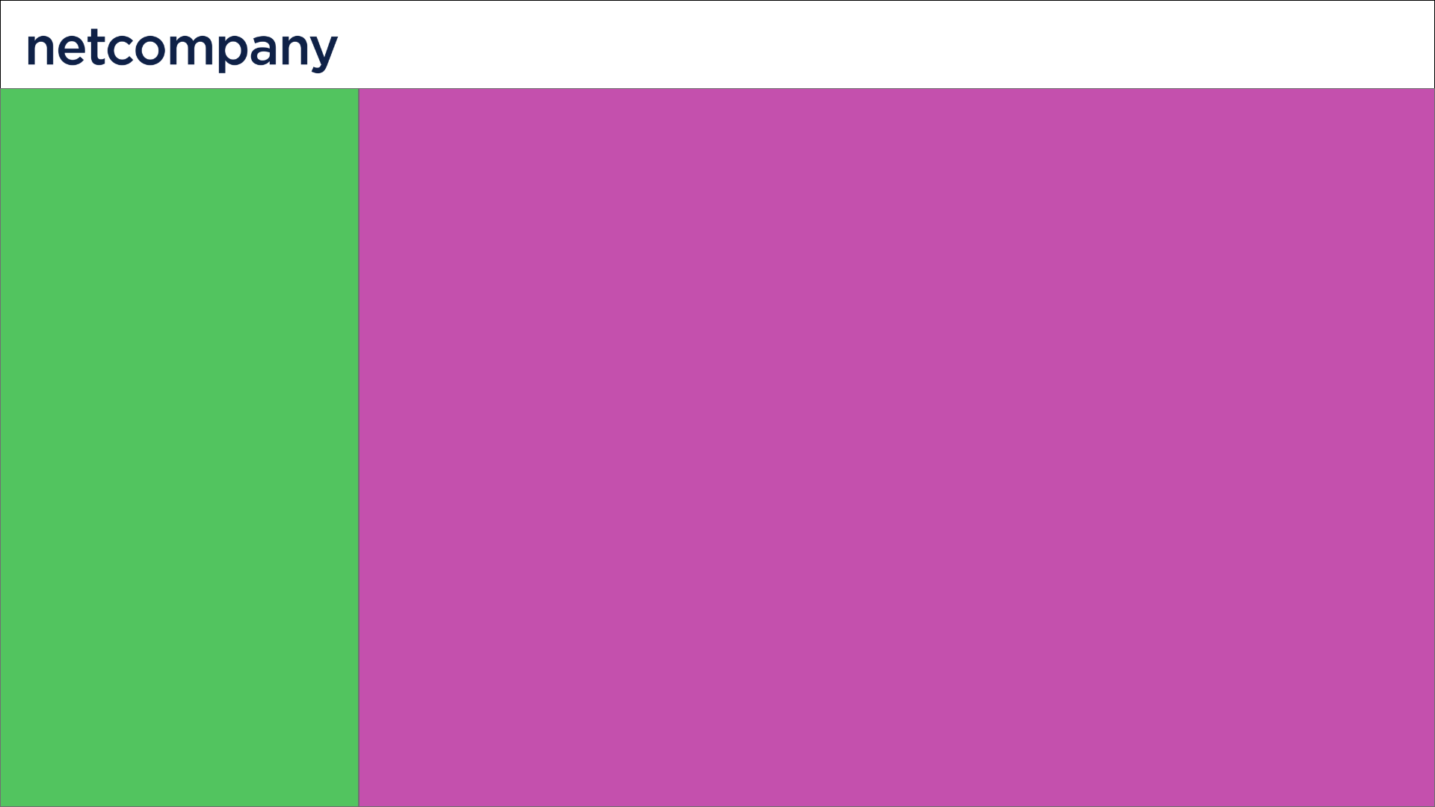

The One Fourth Right Without Header template uses the full width of the browser viewport and is divided into a left and right area. Notice that this template will have fixed navigation in the header.

On mobile devices the left area (marked in green) will be stacked on top of the right area (marked in purple).

### 

### Dashboard (Admin/Staff)

As shown in Figure 1 the Dashboard will consist of multiple components. The top left corner will be the Logo of NCP admin Dashboard. On the left of the screen, there will be a navigation bar, in the center there will be summaries of different components and at the bottom there will be some statistical graph components.

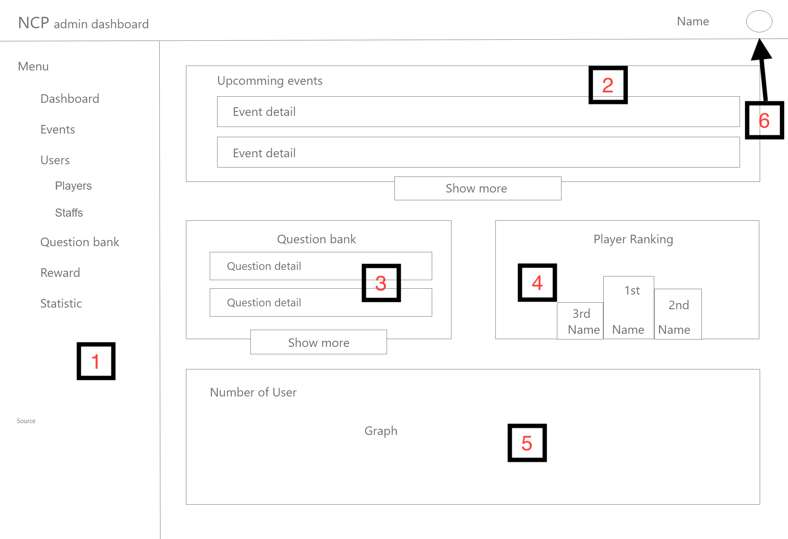

Figure 1 - Dashboard wireframe

|  |  |  |
| --- | --- | --- |
| Footnote | Component Name | Note |
| 1 | Dashboard Menu / Navigation Menu | The navigation menu leads the current user information to the corresponding feature section.  This component will be used throughout the **2.6.1** section and will not be mentioned again. |
| 2 | Upcoming Event | The component summarizes the information of upcoming events. Clicking the ‘Show more’ button will take the user to ‘Overview of all events’ (see section **2.6.1.1**) |
| 3 | Question Bank | The component summarizes the information of all questions (total question, total approved questions of the users). Clicking the ‘Show more’ button will take the user to ‘Overview of the question bank’ (see section **2.6.1.1**) |
| 4 | Player Ranking | The component shows the top 3 highest players ranked by their earned netcoins. |
| 5 | Graph | The component shows statistical data of users (total players, new players daily, weekly and monthly), questions and events (using graph). |
| 6 | Avatar icon | The top right corner will be the name and the avatar of the current user. Clicking on the avatar will pop up the current user personal section (see figure 2)  This component will be used throughout the **2.6.1** section and will not be mentioned again. |

The personal section contains the current user information, information management feature and a logout option. (Figure 2)

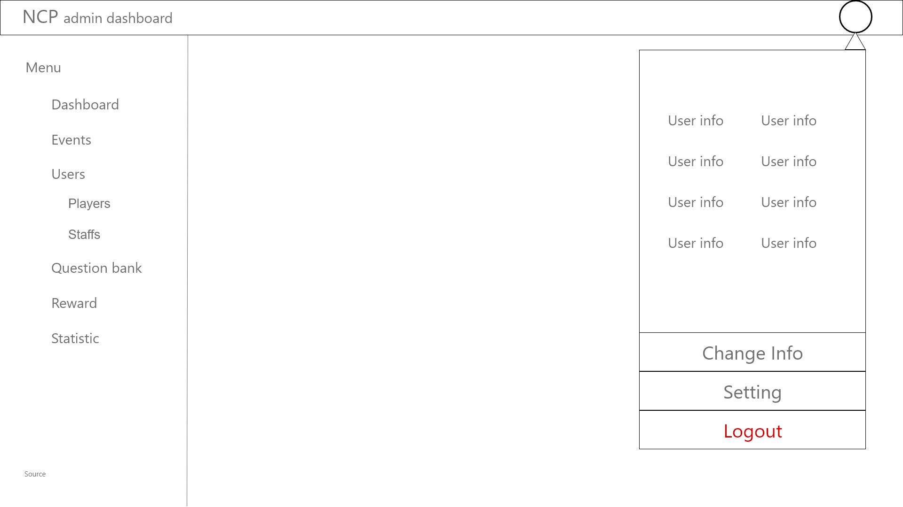

Figure 2 - Dashboard - Personal Section Wireframe

#### 

#### Overview of all events

As the figure shows (figure 3), we can see that the page consists of two main parts.

The first part is about the ongoing event which is listed in detail (ID, name, category, date and time start, date created, core keyword and the remaining time of the event). It also contains a button that leads to the create a new event section.

The second part is the list of all events of the system. The events are listed with their information (ID, name, theme, date and time start, date created, core keyword and created by who), if the list is long enough, it will be automatically splitted into many pages.

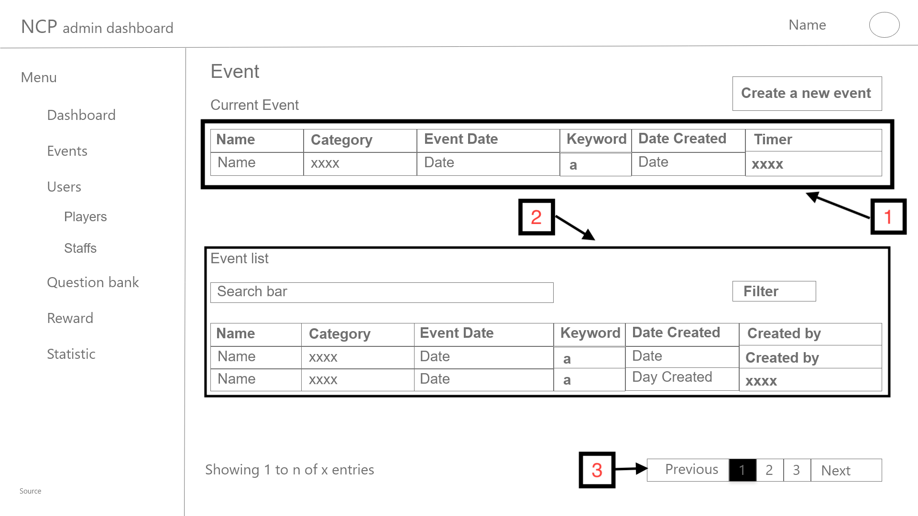

Figure 3 - Dashboard - Event wireframe

|  |  |  |
| --- | --- | --- |
| Footnote | Component Name | Note |
| 1 | Current event | This component displays the current events (happening events) ordered by date.  Clicking the ‘Create a new event’ above will take the user to the create screen (see section **2.6.1.1.3**) |
| 2 | Event list | The component consists of a table of all events (ordered by their created date).  There will also be a search bar by name and a filter box (by category and date). |
| 3 | Pagination | Click ‘Previous’, ‘Next’ or any number in the pagination will show the corresponding data based on ‘n’.  This component will be used throughout this document so it will not be mentioned again. |

##### 

##### Current event

The main container of the page will consist of the data information (event name, keyword, category, label, start time, and participant list, the participant list will contain the rank, email, name and joined time, if there are many participants, the list will be splitted into pages). The top left corner of the container will have a back button that would lead the user back to the previous layout.

The right part of the main container there will be a small container which is a preview as a player perspective. The small container includes the event name, event description, countdown timer, staff announcements and staff announcement input field and send button.

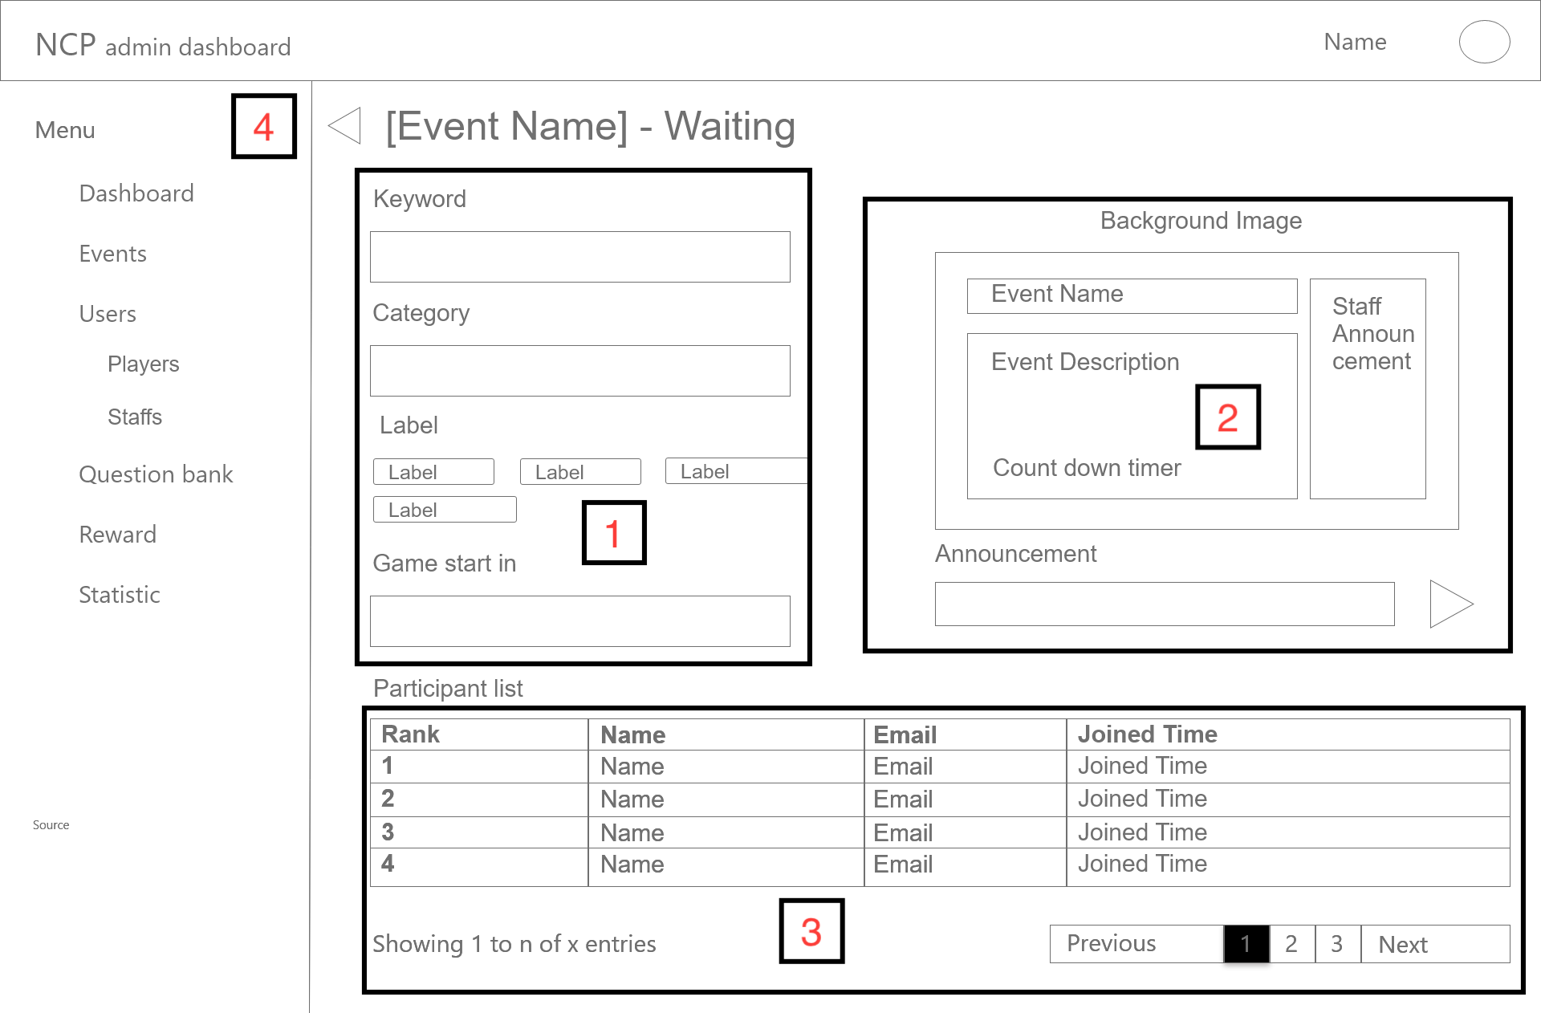

Figure 4- Dashboard - Event - Current event waiting room

|  |  |  |
| --- | --- | --- |
| Footnote | Component Name | Note |
| 1 | Current event information | This component will consist of the following information: event name, keyword, category, labels and start time. Click on a row will take the user to the ‘Upcoming event’ screen |
| 2 | Current event preview | A small container which is a preview as a player perspective. The container includes the event name, event description, countdown timer with a background image, staff announcements and staff announcement input field and send button (which will popup a confirmation box). |
| 3 | Participants list | The component shows all participants ranked and ordered by their joined time, which will be changed later. |
| 4 | Back button | Clicking the button will take the user back to the ‘Overview of all events’ screen.  This component will be used throughout this document so it will not be mentioned again. |

When the event starts, the waiting layout becomes the starting layout (Figure 5). This layout (Figure 5) will have almost the same information as the previous layout (Figure 4), but there will be a timer to show the time left of the event instead of the game start in timer. The participant list will have 1 more column, that is the time submitted which indicates the time that the players submitted their answer and the joined order will become the player’s rank in the event.

The top left corner of the container will have a back button that would lead the user back to the previous layout. After the time is up, the page layout (Figure 5) will change to the finished event layout.

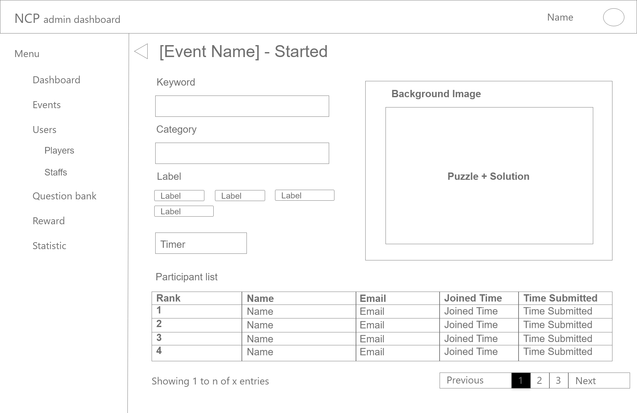

Figure 5 - Dashboard - Event - Current event started room wireframe

|  |  |  |
| --- | --- | --- |
| Footnote | Component Name | Note |
| # | Participant list | The component will be changed to being ranked by the submitted time. |
| # | Current event preview | The component will be changed to the completed puzzle with solutions, including a background image. |

This layout (Figure 6) will have almost the same information as the previous layout (Figure 5), but in the participant list, instead of displaying the joined time it will display the rank of the player and also it has one more column that is the earned Netcoin.

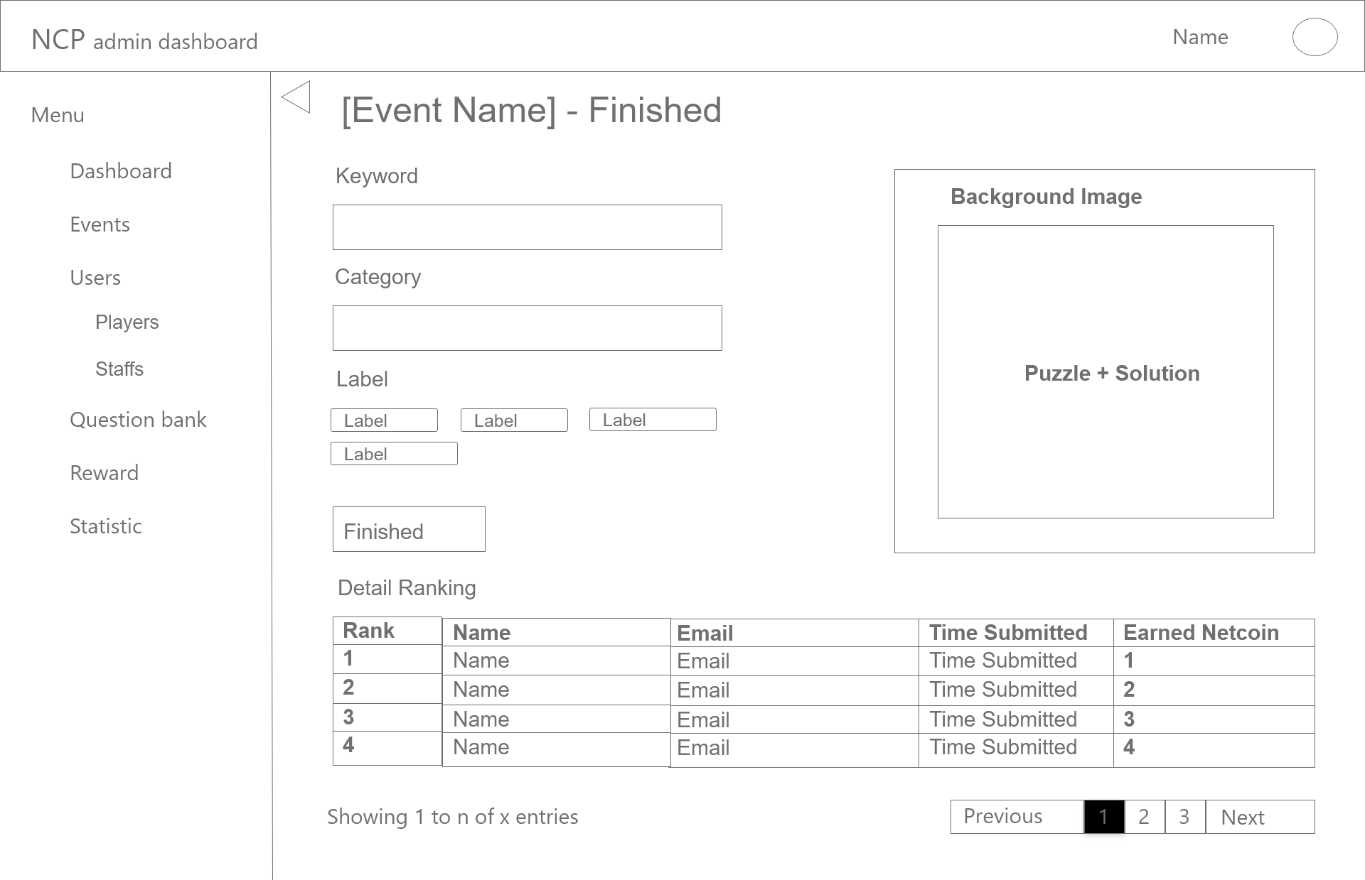

Figure 6 - Dashboard - Event - Current event finished room

|  |  |  |
| --- | --- | --- |
| Footnote | Component Name | Note |
| # | Participant list | The component will be changed to being ranked by the answer (if is correct) and submitted time. |

##### Upcoming event

The layout (Figure 7) shows the detailed information of the clicked event and it can be edited.

The main container of the layout consists of the information fields of the event.

On the top right corner of the main container of the layout, there is a preview box which can show the player perspective of that event.

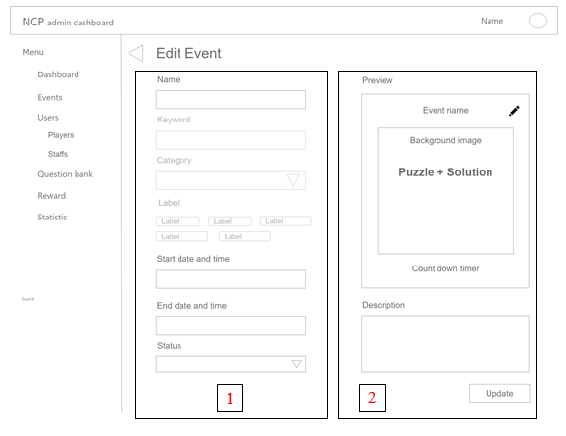

Figure 7 - Dashboard - Event - Upcoming event wireframe

|  |  |  |
| --- | --- | --- |
| Footnote | Component Name | Note |
| 1 | Upcoming event information | The component consists of the information fields of the event (event name, keyword, category, labels, starting date and time, event description and status of the event - draft, published or canceled) which can be edited except for the keyword, category and labels. |
| 2 | Upcoming event preview | At the top corner of the preview panel, there is a  button that lets the user change the background of the event.  The Update button will confirm and save the information of the edited fields. |

##### Create new event

The purpose of this layout (Figure 8) is to let the user create a new event for players.

The layout consists of all of the event information. The right part of the layout is the preview of the event puzzle.

There are two buttons at the bottom right corner of the layout.

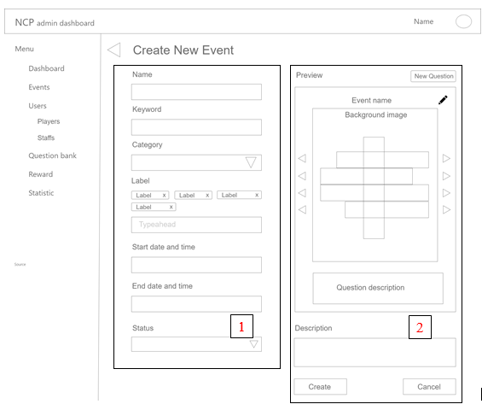

Figure 8 - Dashboard - Event - Create new event wireframe

|  |  |  |
| --- | --- | --- |
| Footnote | Component Name | Note |
| 1 | Create new event | The component consists of the following fields - name, keyword, category, labels, starting date and time and status (draft, publish or cancel). A publish event will be shown as an upcoming event |
| 2 | New event preview | The crossword puzzle is in the middle of the container with its keyword, there are previous and next buttons on both sides of the puzzle that helps the user change the keyword of that line.  The ‘Create button’ which helps the user to save and create the new event. The ‘Cancel button’ which cancels the data and leads the user back to the previous layout (Figure 3).  The  button lets the user change the background of the event. And there is also a new question button on the top of the preview panel.  Clicking on the new question button the layout will lead the user to the add question layout (Figure 10) (nice to have feature). |

#### Overview of question bank

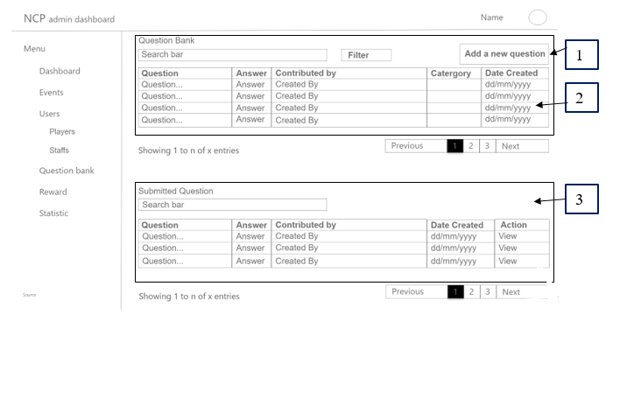

Figure 9 - Dashboard - Question bank wireframe

The display (Figure 9) shows the user the question bank of the system with their general information(. And also the submitted question part where display the submitted questions by the player that are waiting for the staff to approve. The display also provides an add new question option.

|  |  |  |
| --- | --- | --- |
| Footnote | Component Name | Note |
| 1 | Create new question button | Clicking on this component will lead to the create question layout (Figure 10) |
| 2 | Question bank list | The question bank listed all the questions with their information(Question, Answer, Contributed By Who, Category and Date Created) which is on top of the container. |
| 3 | Submitted question waiting for approve | This section shows the submitted questions by the players by list with their information(ID, Question, Answer, Contributed by, Category, Date Created and action button) |

#### 

##### Add a new question

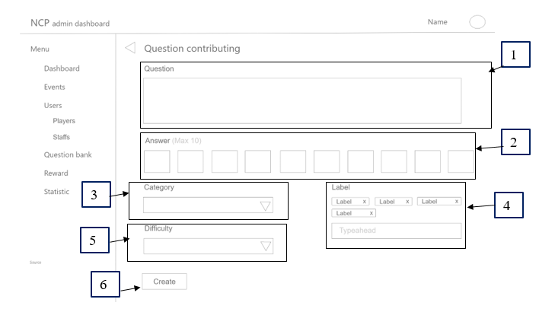

Figure 10 - Dashboard - Question Bank - Adding a new question wireframe

The purpose of this layout (Figure 10) is to let the current user (staff) add a new question into the question bank.

|  |  |  |
| --- | --- | --- |
| Footnote | Component Name | Note |
| 1 | Question content input | Let the user input the content of the question |
| 2 | Answer keyword input | Let the user input the keyword of the answer (max 10, no special characters) |
| 3 | Category | Clicking on this component will show a dropdown section that shows all of the categories of the question. |
| 4 | Label | This component is a typeahead, and will only appear when only choosing a category. |
| 5 | Difficulty | Clicking on this component will show a dropdown section that shows all of the difficulties of the question (1-10). |
| 6 | Create question button | Clicking on the button will show a pop-up layout that confirm to save the information |

#### 

##### View a question

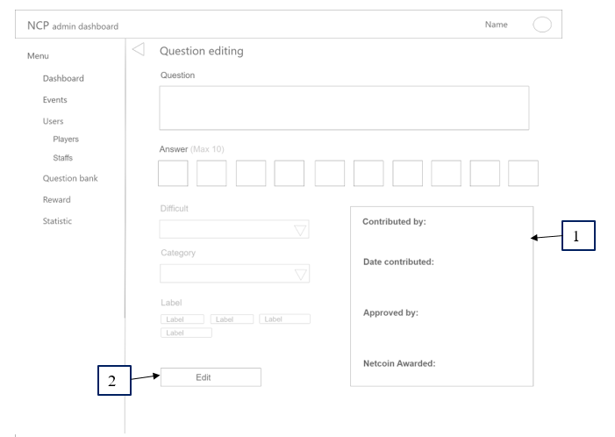

Figure 11 - Dashboard - Question Bank - View question wireframe

This layout (Figure 11) will appear after clicking on a specific question in the question bank layout (Figure 9). This layout shows the detailed version of the question, also the fields can be edited.

|  |  |  |
| --- | --- | --- |
| Footnote | Component Name | Note |
| 1 | Question detailed information | The component contains all related information of the question contributed by, date contributed, approved by and netcoin awarded fields which are not editable) |
| 2 | Edit button | The button that lets the current user (staff) to save the edited fields which are changed. |

##### Approving a question

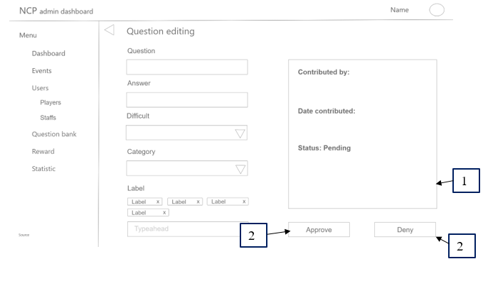

Figure 12 Dashboard - Question Bank - Approve question wireframe

This layout (Figure 12) will appear after clicking on a specific question in the submitted question list which is in the question bank layout (Figure 9). This layout shows the detailed version of the submitted question, also the fields can be edited.

The layout contains all related information of the question (question, answer, difficulty, category, label which is editable and also the contributed by, date contributed and status of the question fields which are not editable)

At the bottom right corner, there is an Approve button that lets the current user (staff) approve the contributed question and add it to the question bank, the Deny button will deny the question and delete it .

|  |  |  |
| --- | --- | --- |
| Footnote | Component Name | Note |
| 1 | Question detailed information | The component contains all related information of the question contributed by, date contributed, and status fields which are not editable) |
| 2 | Approve button | The button that lets the user accept the contributed question to the question bank. |
| 3 | Deny button | The button that lets the user deny the contributed question. |

### Overview of the user information

This section has two other small sections: Player overview and Staff overview.

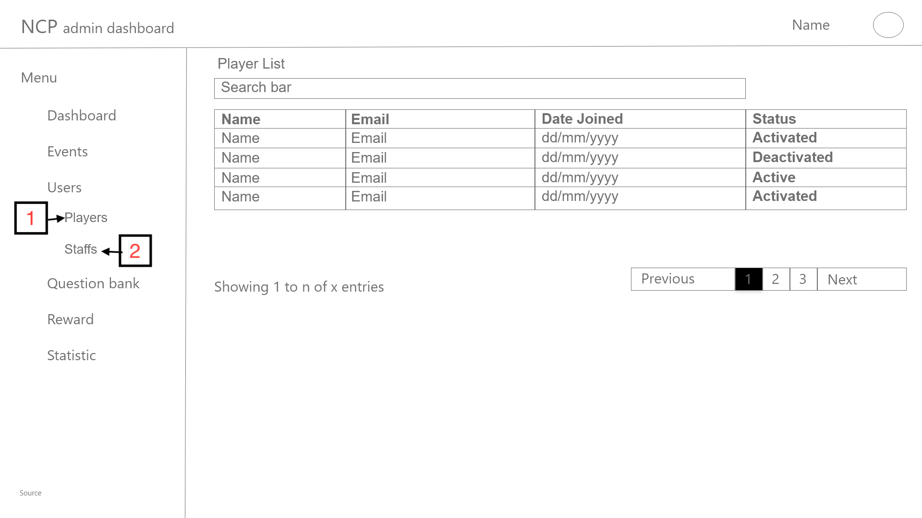

Figure 13.1 - Dashboard - Users - Player List wireframe

This layout (Figure 13.1) helps the user to quickly look through all of the players in the system in list with their general information. The layout consists of a search bar and sorting with each information column.

The list contains the general information of the user (name, email, date joined, status(activate, deactivate)). Clicking on each of the users will lead to the corresponding detailed profile page of that particular user.

The list also will have pagination if it is too long.

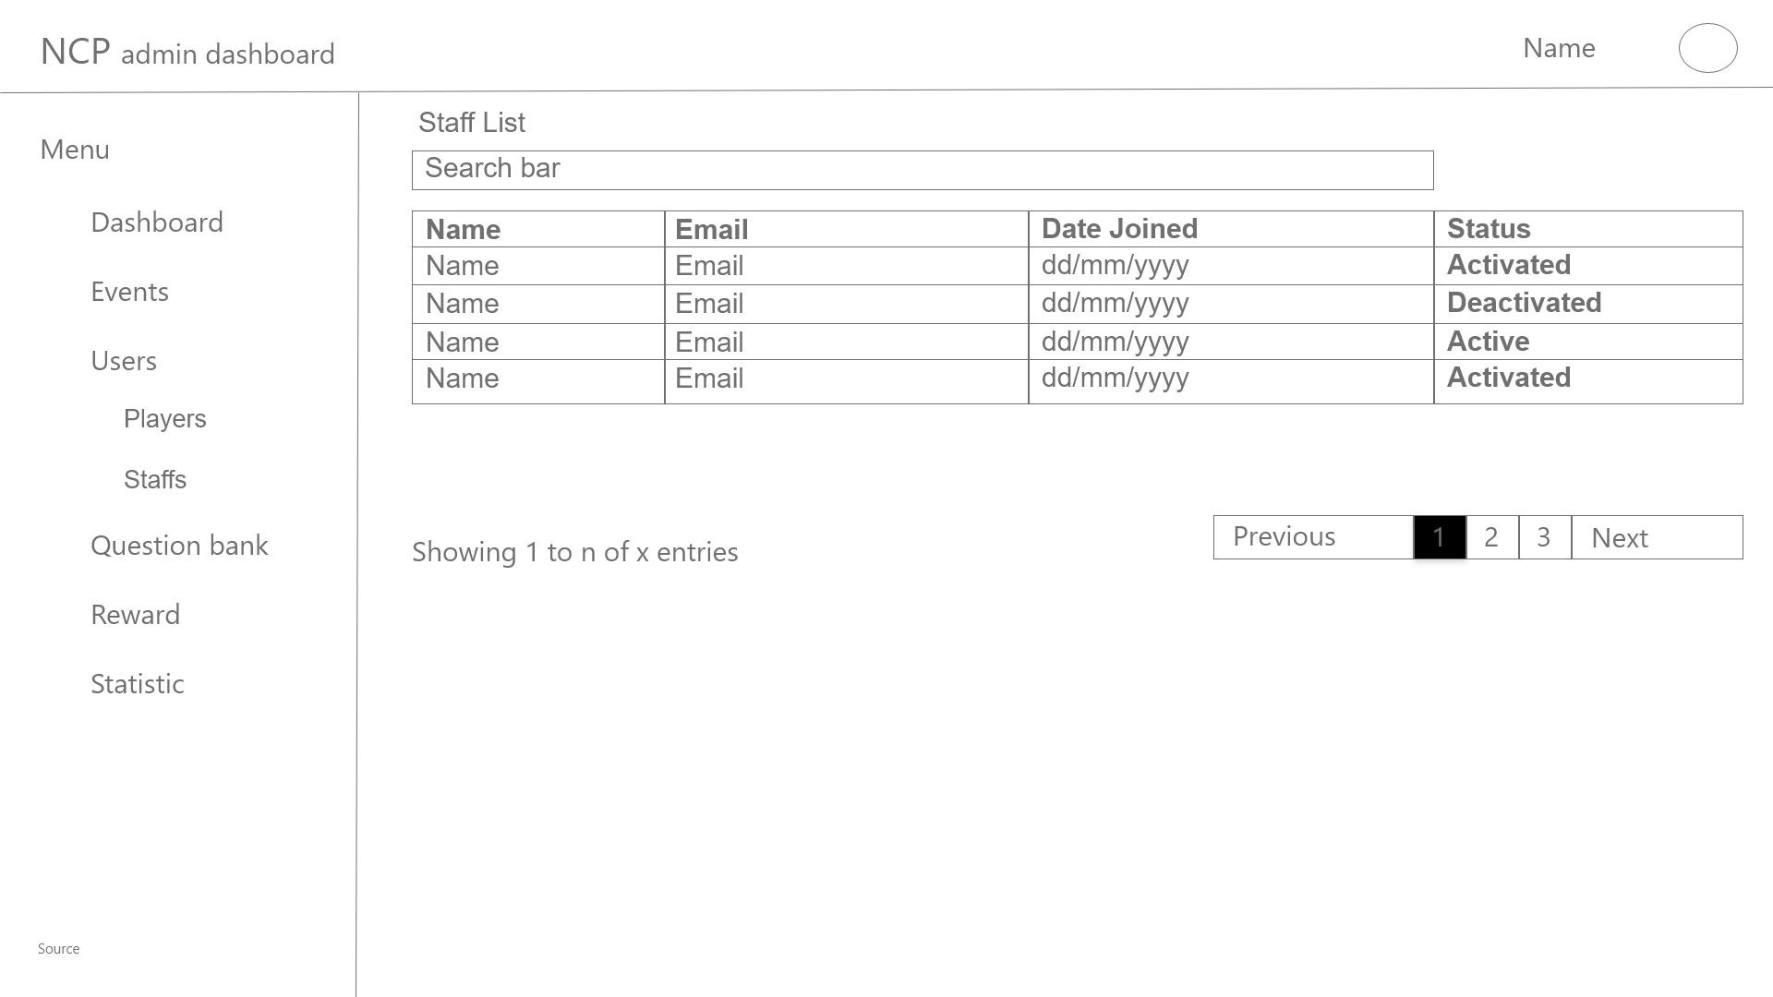

Figure 13.2 - Dashboard - Users - Staff List wireframe

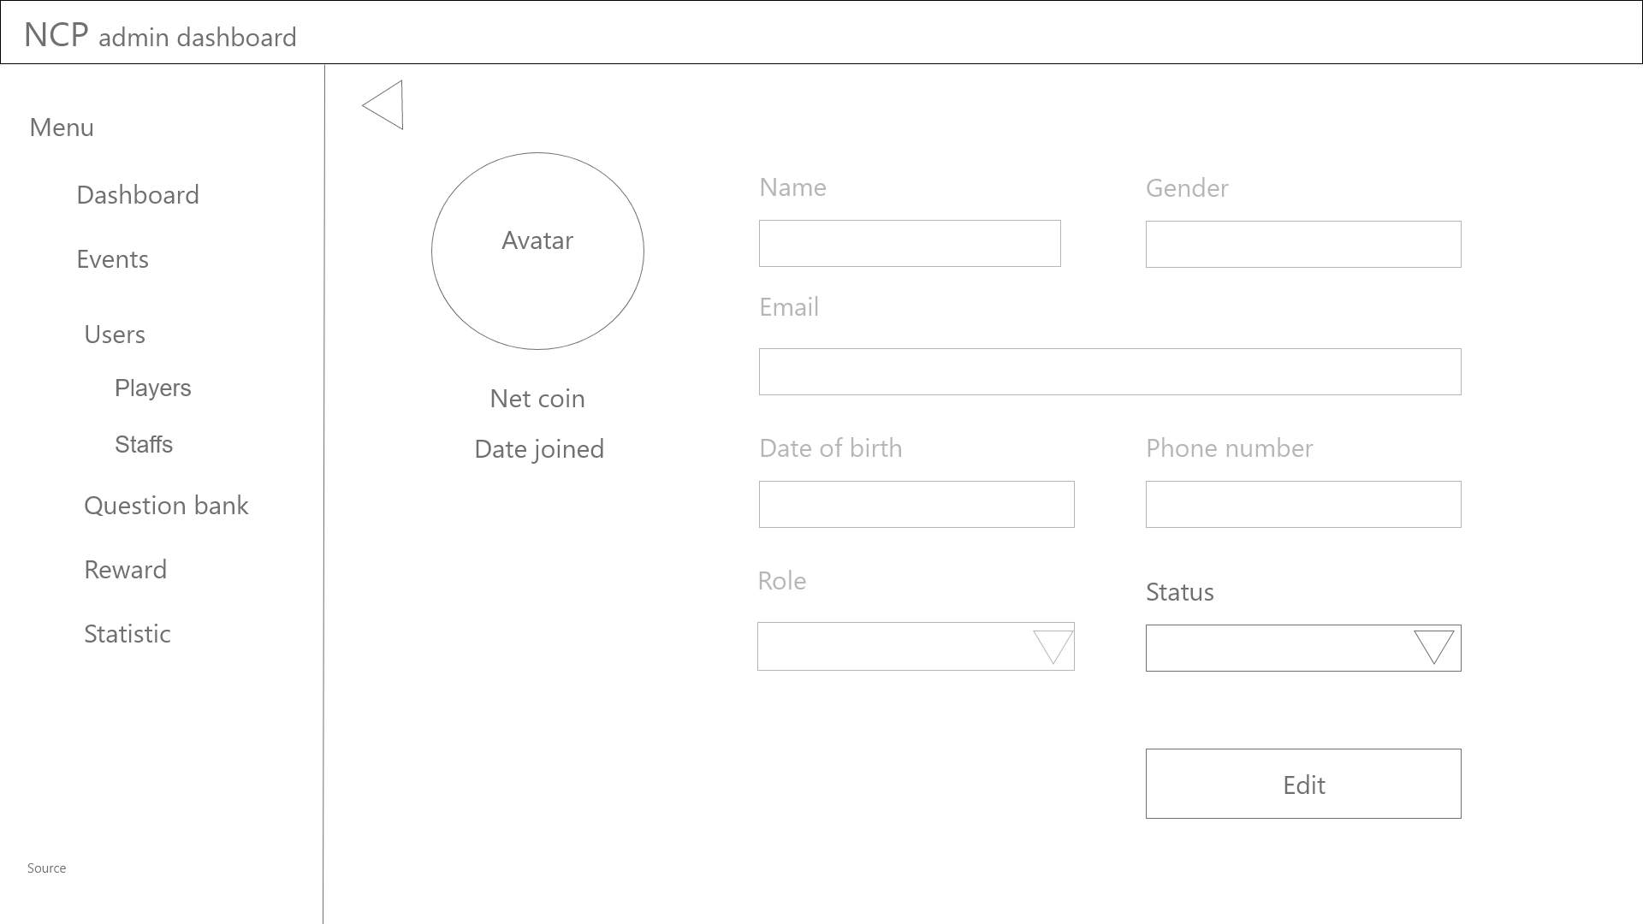

Figure 14 - Dashboard - Users - User profile wireframe

The main container of this layout (Figure 14) consists of information fields of the user(avatar picture, name, gender, date of birth, email, phone number, role (player, staff/admin once the role has been set to staff/admin, the role can not be set back to player and vice versa) and status (activate, deactivate) which are editable.

There are two buttons in this main container, the first one is the Back button which leads the user to the previous layout. The second button is the Edit button - clicking it will popup a confirmation box, which confirms and saves the edited information that the user has changed.

### Overview of the rewarding

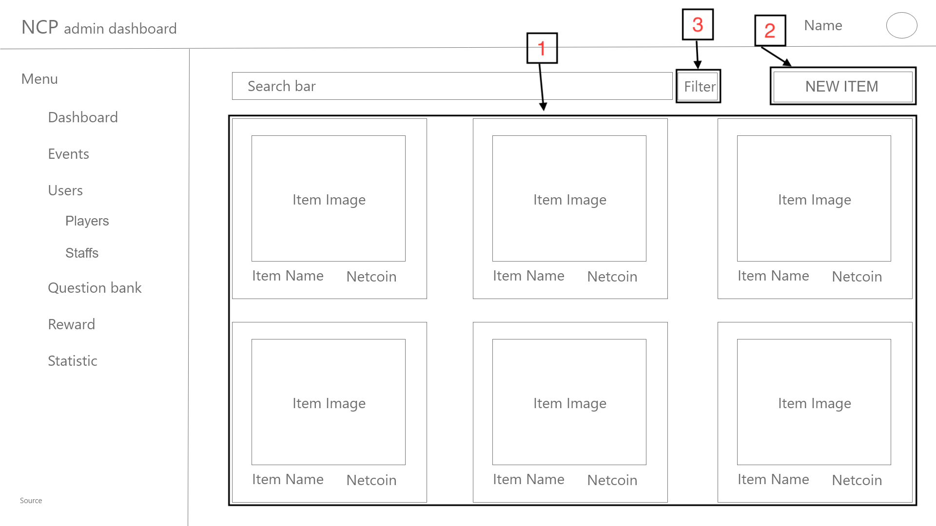

Figure 15 - Dashboard - Reward Manage wireframe

The purpose of this layout (Figure 15) is to let the user see the list of all items of the exchanging system with general information (Name, photo, Netcoin cost).

The main container of this layout contains many small containers which are items. Each of the small containers is included with the item photos, item name and item cost. There is also a search bar and a filter tab.

The button at the top right corner is the add new item button.

|  |  |  |
| --- | --- | --- |
| Footnote | Component Name | Note |
| 1 | Reward list | The component contains general information of all rewards (come with a search bar by name).  Clicking on each item will lead to the detailed information page of that item. |
| 2 | ‘NEW ITEM’ button | The button takes the user to create a new reward item page. |
| 3 | Filter button | Popup a filter box by price range, quantity range, status (will be updated) |

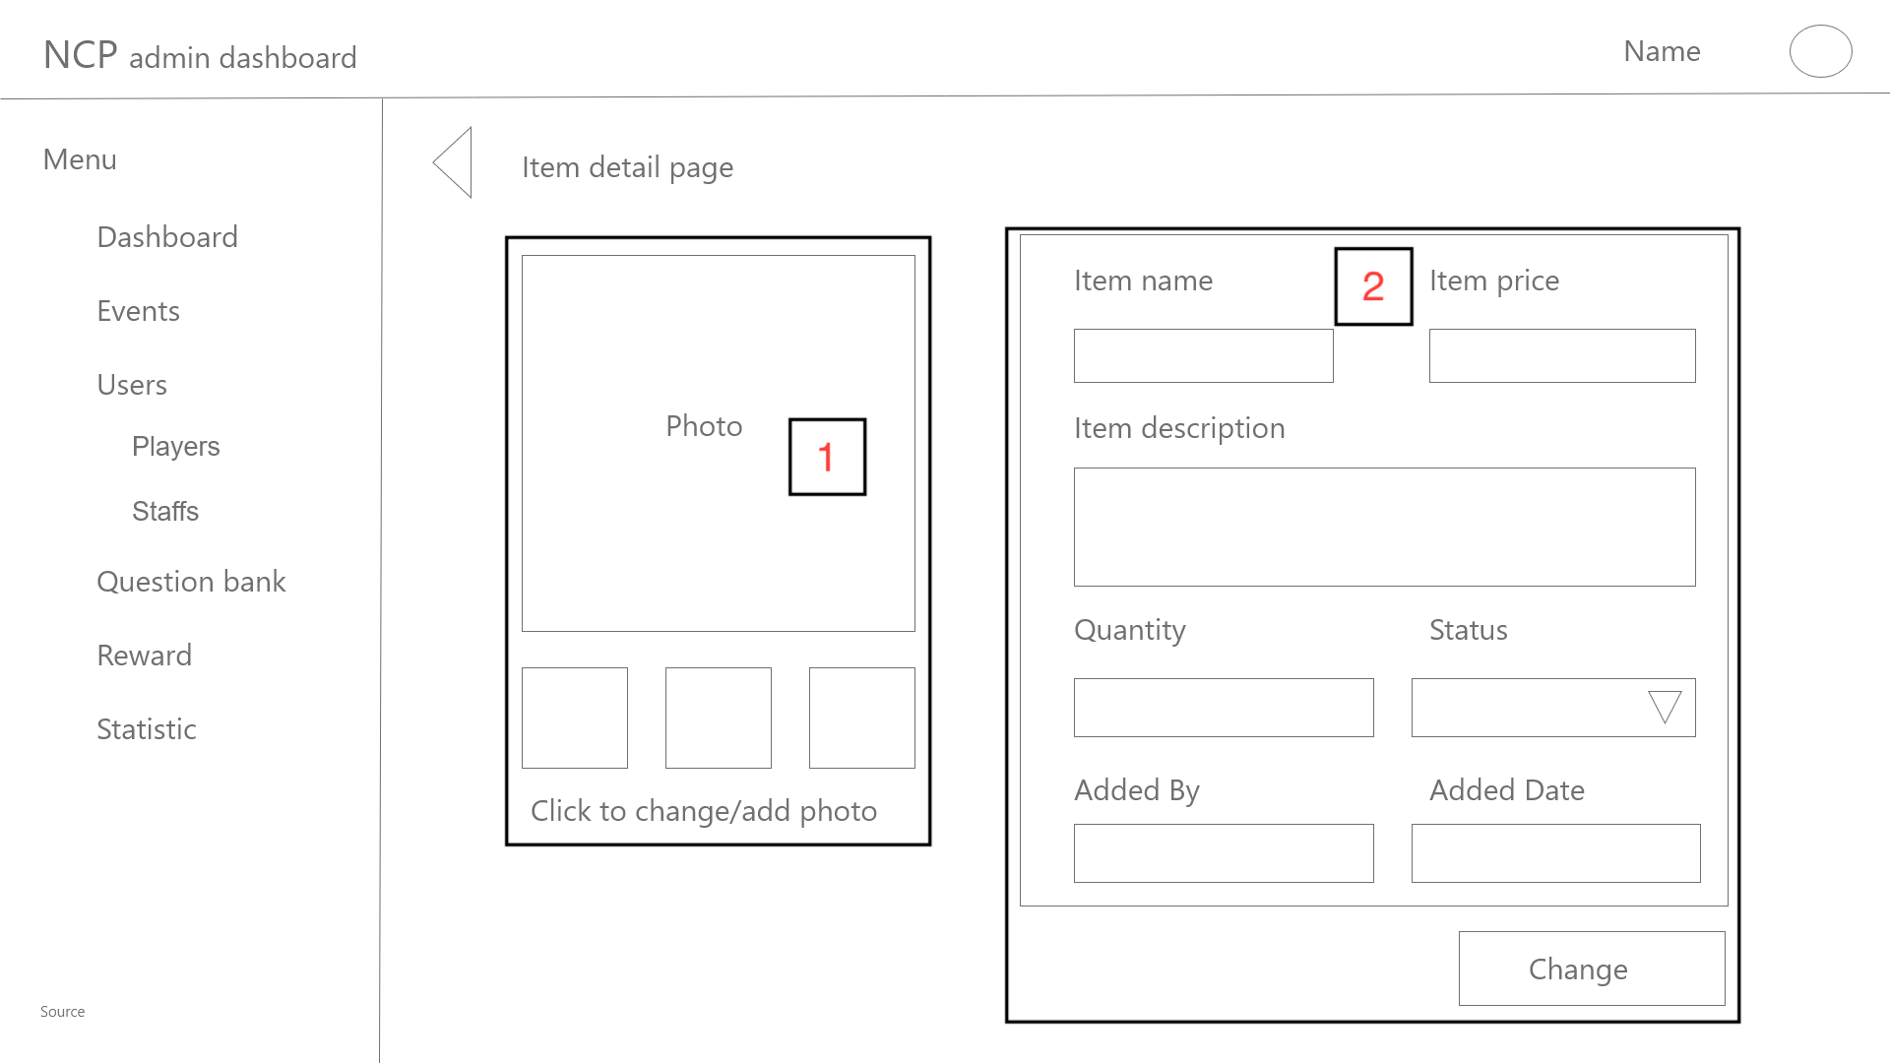

Figure 16 - Dashboard - Reward Manage - Item detailed wireframe

After clicking at an item in the Reward Manage layout (Figure 15), this layout (Figure 16) appears. The purpose of this layout is giving the user a detailed view of the corresponding item.

The layout consists of the item information fields which are editable. The left part of the layout is about the item photos, which can be added/changed or deleted.

There are two buttons in this layout, the first one is the Triangle button which leads the user back to the previous layout and the other one is the Change button which lets the system save the edited information fields that have been changed by the user.

|  |  |  |
| --- | --- | --- |
| Footnote | Component Name | Note |
| 1 | Photos | The component allows the user to add / edit one or more photos of an item |
| 2 | Editable fields | The component contains the following fields: name, price, description, quantity, status, added by, added date. The status field will be ‘Available’ or ‘Not Available’  Clicking the change button will popup a confirmation box to confirm the change of the item. |

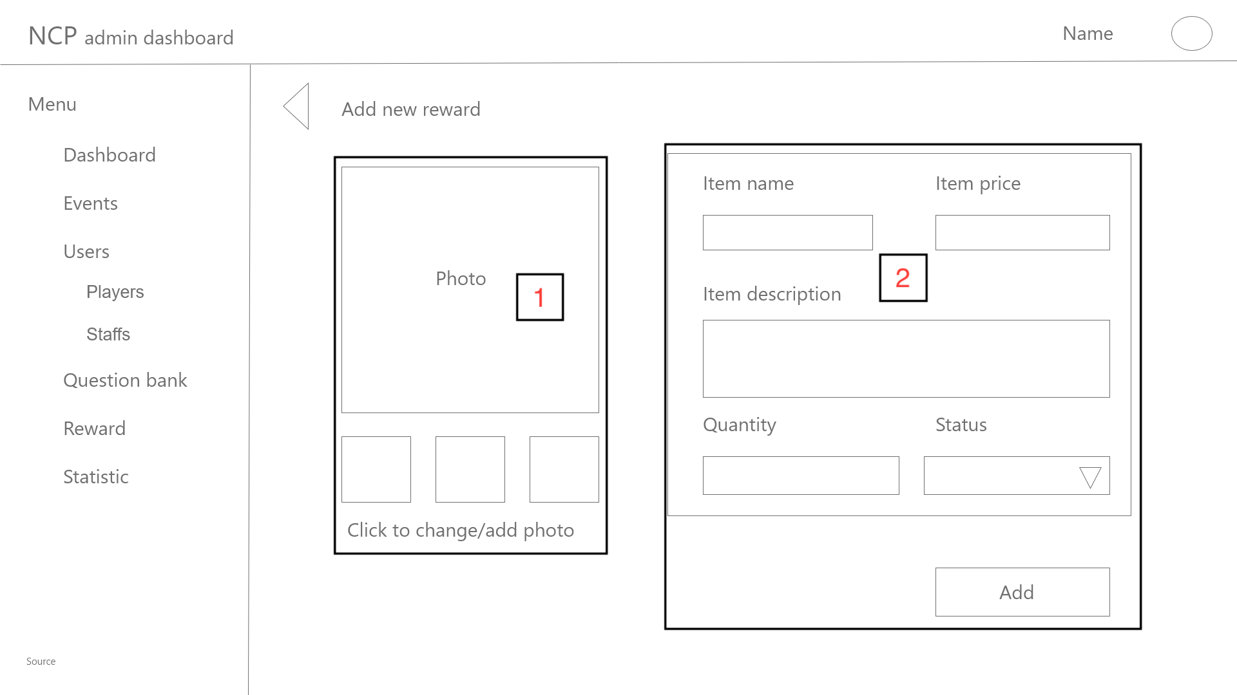

Figure 17 - Dashboard - Reward Manage - Add new reward wireframe

The layout (Figure 17) lets the user add a new exchanging item to the system. The left part of the layout is about the item photos, which can be added, changed or deleted. The left part of the layout is about the item photos, which can be added/changed or deleted.

There are two buttons in this layout, the first one is the Triangle button which leads the user back to the previous layout and the other one is the Change button which lets the system save the edited information fields that have been changed by the user.

|  |  |  |
| --- | --- | --- |
| Footnote | Component Name | Note |
| 1 | Photos | The component allows the user to add / edit one or more photos of an item |
| 2 | Editable fields | The component consists of the following editable item information fields: name, price, description, amount, status.  The status field will be ‘Available’ or ‘Not Available’  Clicking the add button will popup a confirmation box to confirm the change of the item. |

## Authentication / Authorization

### Authentication / Authorization

This authentication page is used to provide authentication for the user to login to their account, the detailed layout is shown in the figure below.

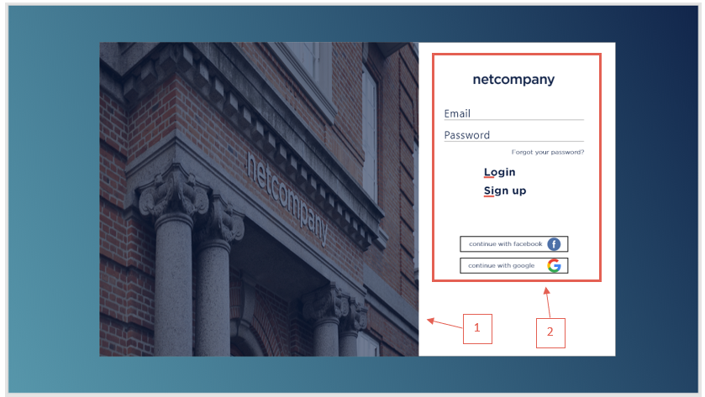

Figure 18 - Authentication / Authorization - Authentication

|  |  |  |
| --- | --- | --- |
| Footnote | Component Name | Note |
| 1 | Homepage Logo Image | A component that allows content editors to upload a Logo image. This component will be added on the placeholder to the left in the layout . |
| 2 | Homepage Sign In form | The Contact Me Form component, as detailed in section 4.14.1 below. This component will be added on the placeholder to the right in the layout (see section 2.8.1.1) |

### 

#### Login form

Figure 19 - Authentication / Authorization - Login form

|  |  |  |
| --- | --- | --- |
| Footnote | Component Name | Note |
| 1 | Login Form | The input for users to fill Email and Password. |
| 2 | Login and Sign up Button | Signup and Login button |
| 3 | Login With Facebook Or Google | Login with Facebook button and Login with Google button. |

### Fail to login

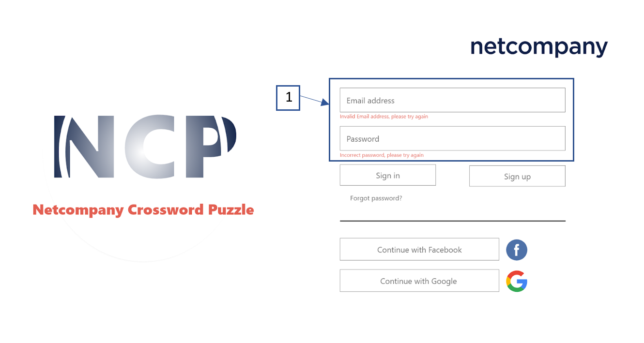

Figure 20 - Authentication / Authorization - Fail to sign in

This layout appears when the information that the user fills in figure 18 is not matching with the information in the database and cannot log the user in.

The basic containers will be the same as figure 19.

Red lines will appear under the input field where the filled information is wrong to announce the error.

### Forgot your password

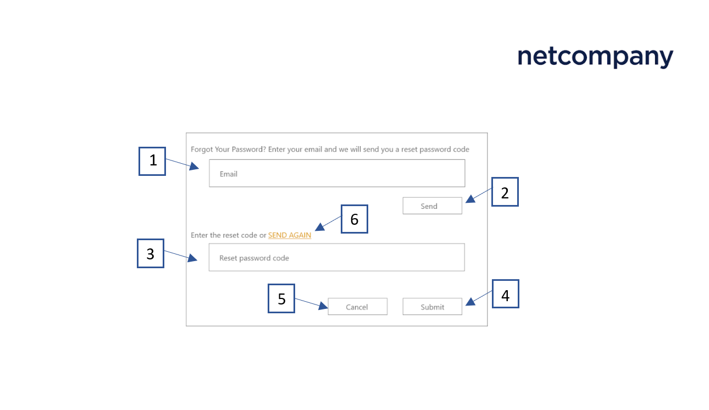

Figure 21 - Authentication / Authorization - Forgot your password

|  |  |  |
| --- | --- | --- |
| Footnote | Component Name | Note |
| 1 | Email Input | The input for users to fill Email. |
| 2 | Send button | Send an email button. |
| 3 | Code input | The input for users to fill Reset Password Code. |
| 4 | Submit button | Submit Reset Password Code button. |
| 5 | Cancel button | Cancel submit Reset Password Code button. |
| 6 | Send again link | Send again Reset Password Code button |

### 

#### Verification code incorrect

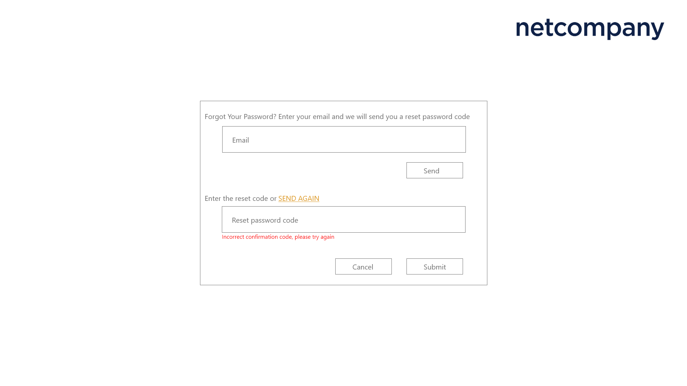

Figure 22 - Authentication / Authorization - Verification code incorrect

The main container of this figure is the same as figure 21. When the verification code which is sent to the email address of the user but the user fills it wrong in the reset password code input fill field, the warning red line will appear under the reset password code input fill field.

### Reset Password

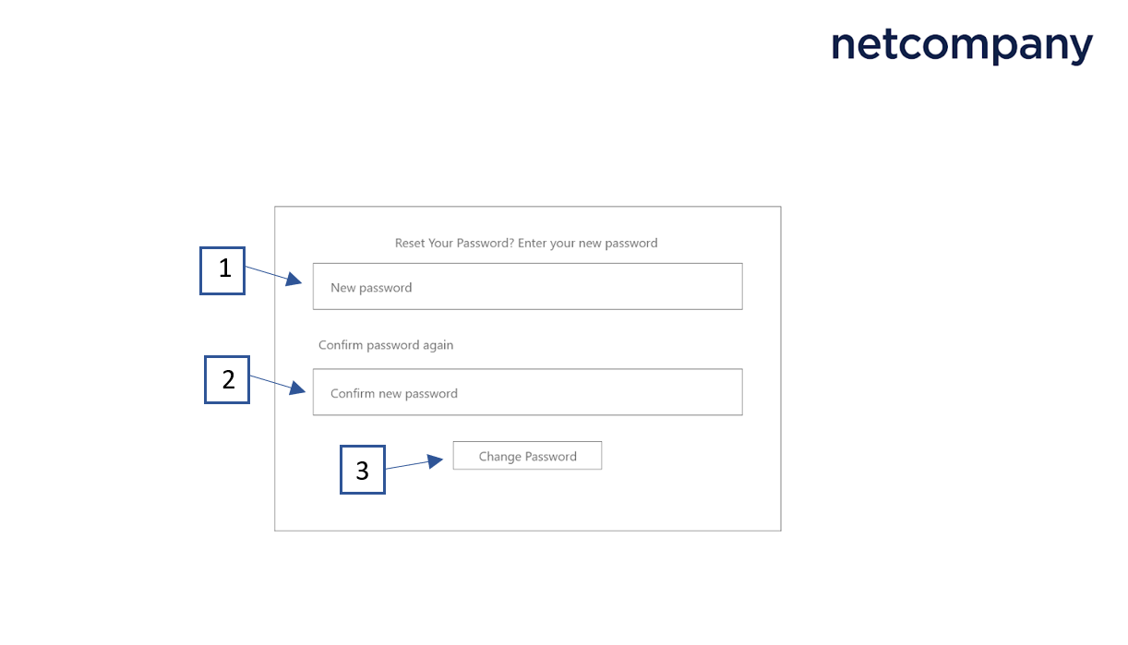

Figure 23 - Authentication / Authorization - Reset Password

|  |  |  |
| --- | --- | --- |
| Footnote | Component Name | Note |
| 1 | New password input | The input for users to fill New Passwords. |
| 2 | Confirm new password input | The input for users to confirm New Passwords. |
| 3 | Reset password | The Confirm Change Password button. |

## 

#### Confirm reset password unmatch

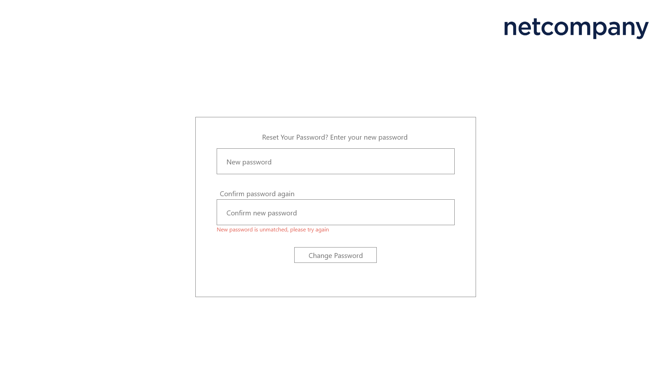

Figure 24 - Authentication / Authorization - Confirm reset password unmatch

The main container of this figure is the same as figure 23. When the user fills the confirm new password input field and it is unmatched with the new password input field , the warning red line will appear under the confirm reset password code input field.

## Player Dashboard

### Main dashboard

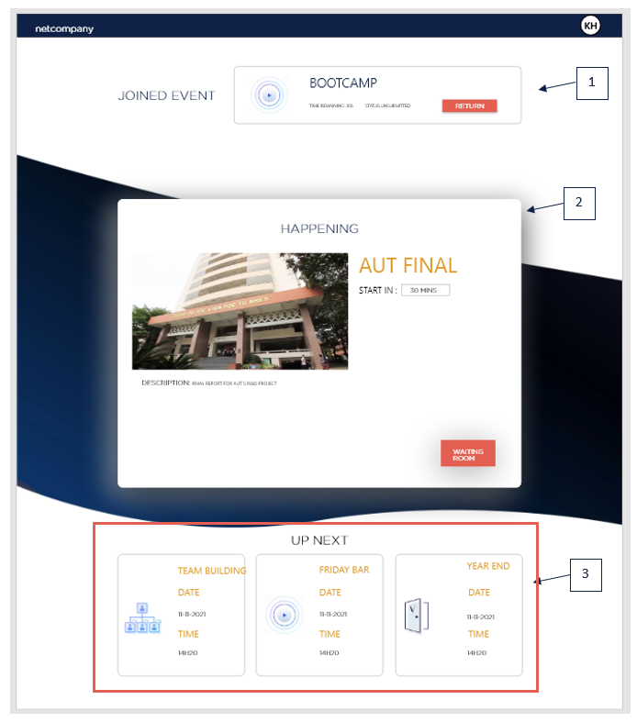

Figure 25 - Dashboard (Player)

|  |  |  |
| --- | --- | --- |
| Footnote | Component Name | Note |
| 1 | Active event | The event that ongoing or the user have already play click ‘Return’ button to return to the event |
| 2 | Starting soon event (within 90 minutes) | The event that will start in about next 90 minutes, click to the ‘Waiting room’ button to join the waiting room |
| 3 | Upcoming event | Upcoming Events. |

### Event Details

#### Ongoing Event Details

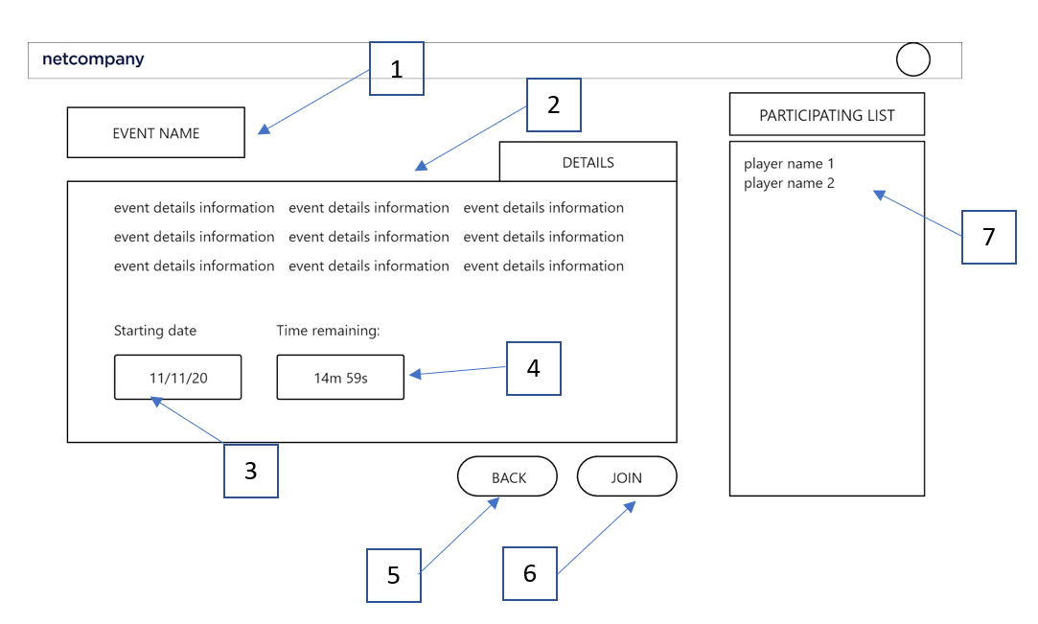

Figure 27 - Dashboard - ongoing event information

|  |  |  |
| --- | --- | --- |
| Footnote | Component Name | Note |
| 1 | Event name | The name of the event |
| 2 | Event detail | The detailed information of the event |
| 3 | Starting date | Event starting date. |
| 4 | Timer | Countdown time to end the game. |
| 5 | Back button | Leads back to the previous layout |
| 6 | Join button | Leads to game room |
| 7 | Participant list | The list of the participant’s name |

#### Upcoming Event Details

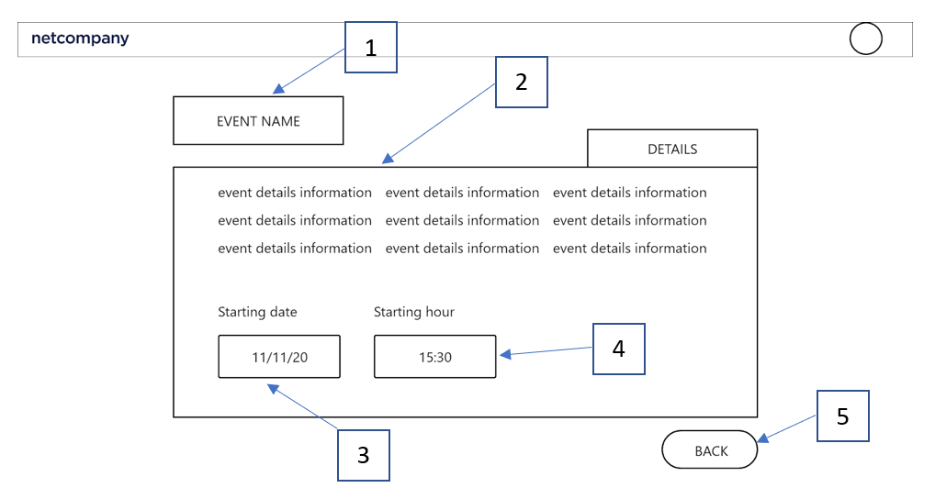

Figure 28 - Dashboard - Upcoming event information

|  |  |  |
| --- | --- | --- |
| Footnote | Component Name | Note |
| 1 | Event name |  |
| 2 | Event detail | The detailed information of the event |
| 3 | Starting date | Event starting date. |
| 4 | Timer | Countdown time to begin of the game. |
| 5 | Back button | Leads back to the previous layout |

### User menu

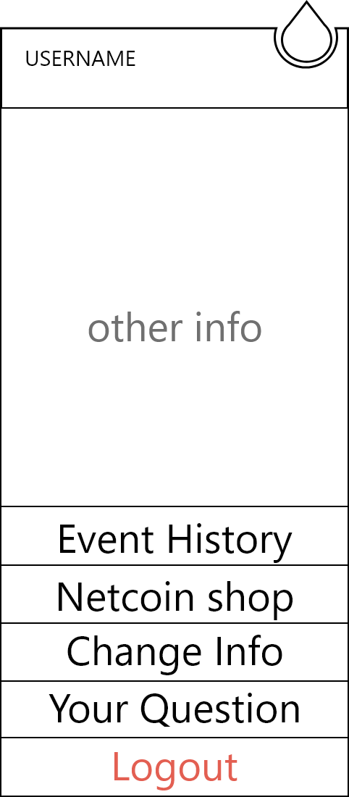

Figure 29 - Dashboard - User menu

This figure will appear as an overlay whenever the user clicks on the avatar in any other figure which has heading with the user avatar and located right below the avatar.

The figure consists of the user's basic information and has 5 buttons including Matching history, Shop, Change information, Contributing and Logout, which when clicked will activate and redirect to their section figure.

## Contributing

In the figure 30, when click on the contribution button, it will redirect to this contributing layout figure

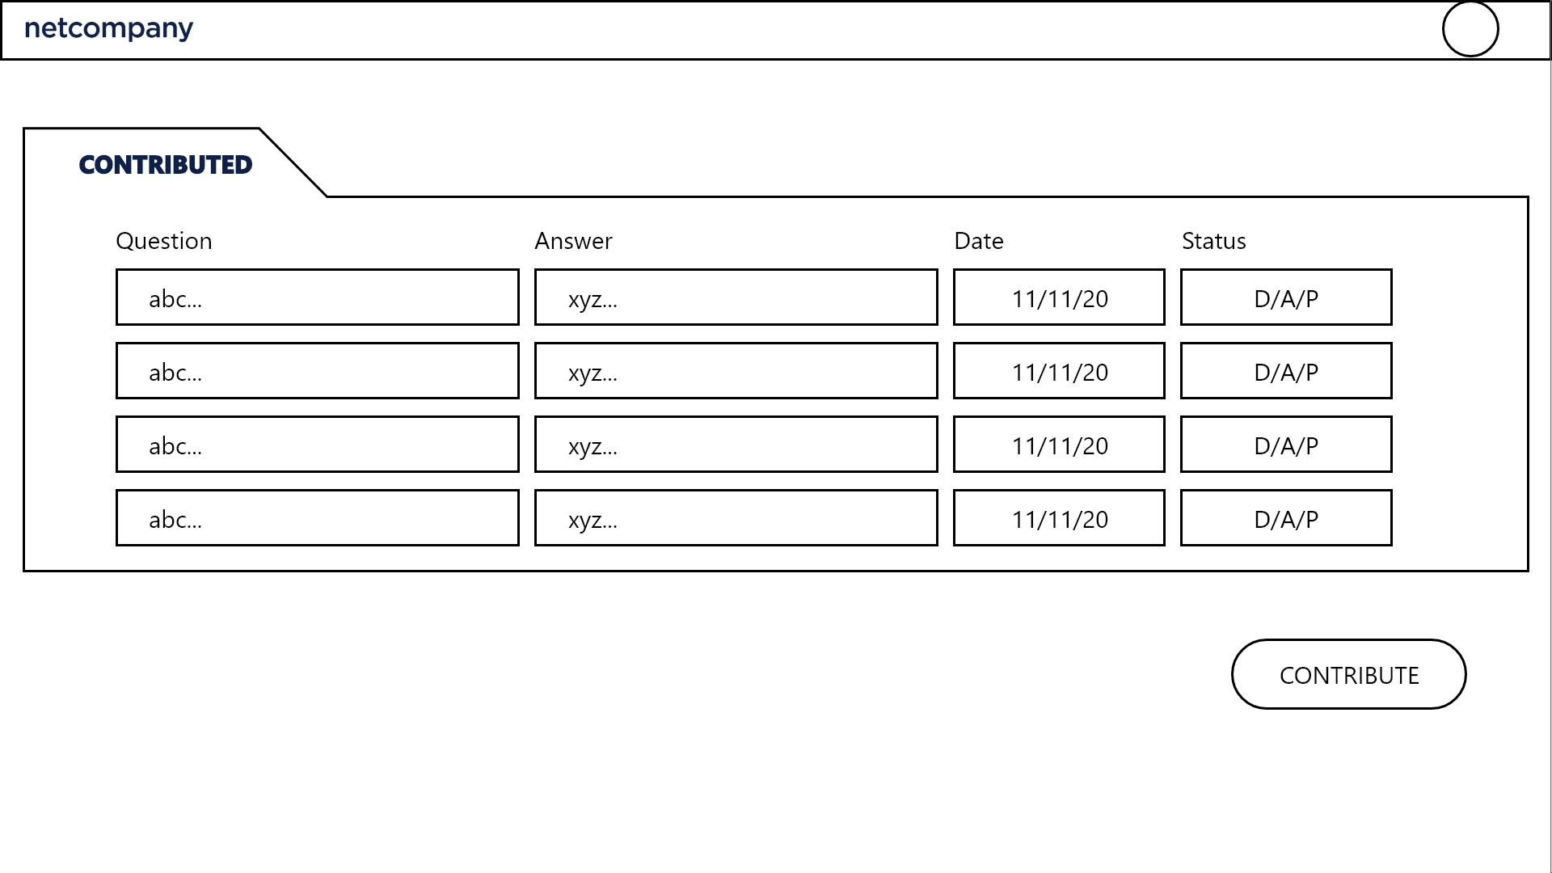

Figure 30 - Contributing - Contributed questions

In the main container of this figure, the contributed question is in the form of a table, including the question, the answer, the date contributed and the status of that question (accepted, denied, pending). Below the contributed question is the contribute button, when clicked it pop-up the contribute form for the user to contribute a new question (figure 31).

### Contribution

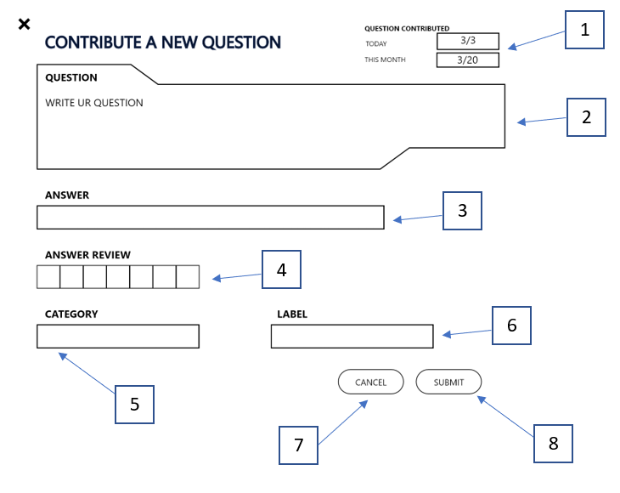

Figure 31 - Contributing - Contribution

|  |  |  |
| --- | --- | --- |
| Footnote | Component Name | Note |
| 1 | Contributed information | Question contributed (questions that the user contributed on that day and in that month). |
| 2 | Question text-box | Click to fill the question. |
| 3 | Answer text-box | Click to fill the answer of the question. |
| 4 | Answer review | See the answer in the puzzle box. |
| 5 | Category | Click to choose the Category of question. |
| 6 | Label | Click to fill the Label of question. |
| 7 | Cancel button | Click to cancel contributing. |
| 8 | Submit button | Click to submit contributing. |

## Rewarding

In figure 24 and figure 33, if a user's question is accepted or the user is in the top 3 player, the user will be rewarded netcoin (see contributing section and gameplay section for more information).

## Exchanging system

#### Netcoin shop

In the figure 23, when click on the Netcoin shop button, it will redirect to this Shop layout figure

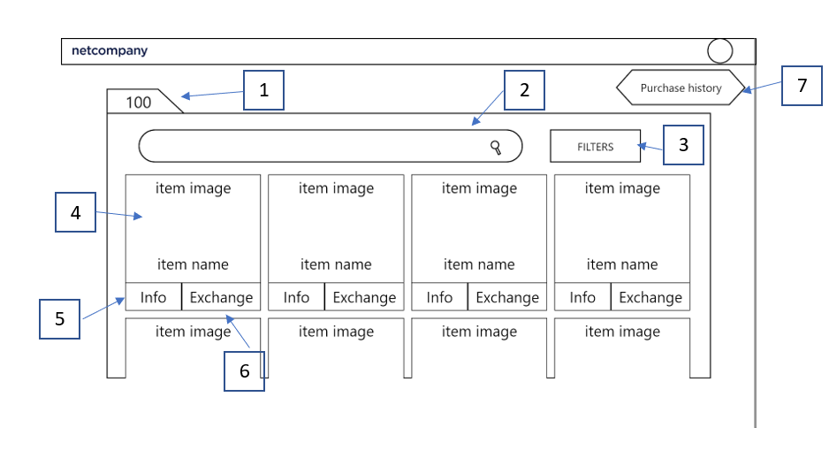

Figure 32 - Exchanging system - Netcoin shop

|  |  |  |
| --- | --- | --- |
| Footnote | Component Name | Note |
| 1 | Netcoin amount | Netcoin that the users have. |
| 2 | Search bar | Click to search for the items. |
| 3 | Filter button | Filters for items (sort items based on price - high to low, low to high and alphabet). |
| 4 | Item information | Item image and name. |
| 5 | item info button | Click to see full the Information of item. |
| 6 | Exchange button | Click to exchange the item. |
| 7 | Purchase history button | Click to see full list of Item purchased |

#### Item Information

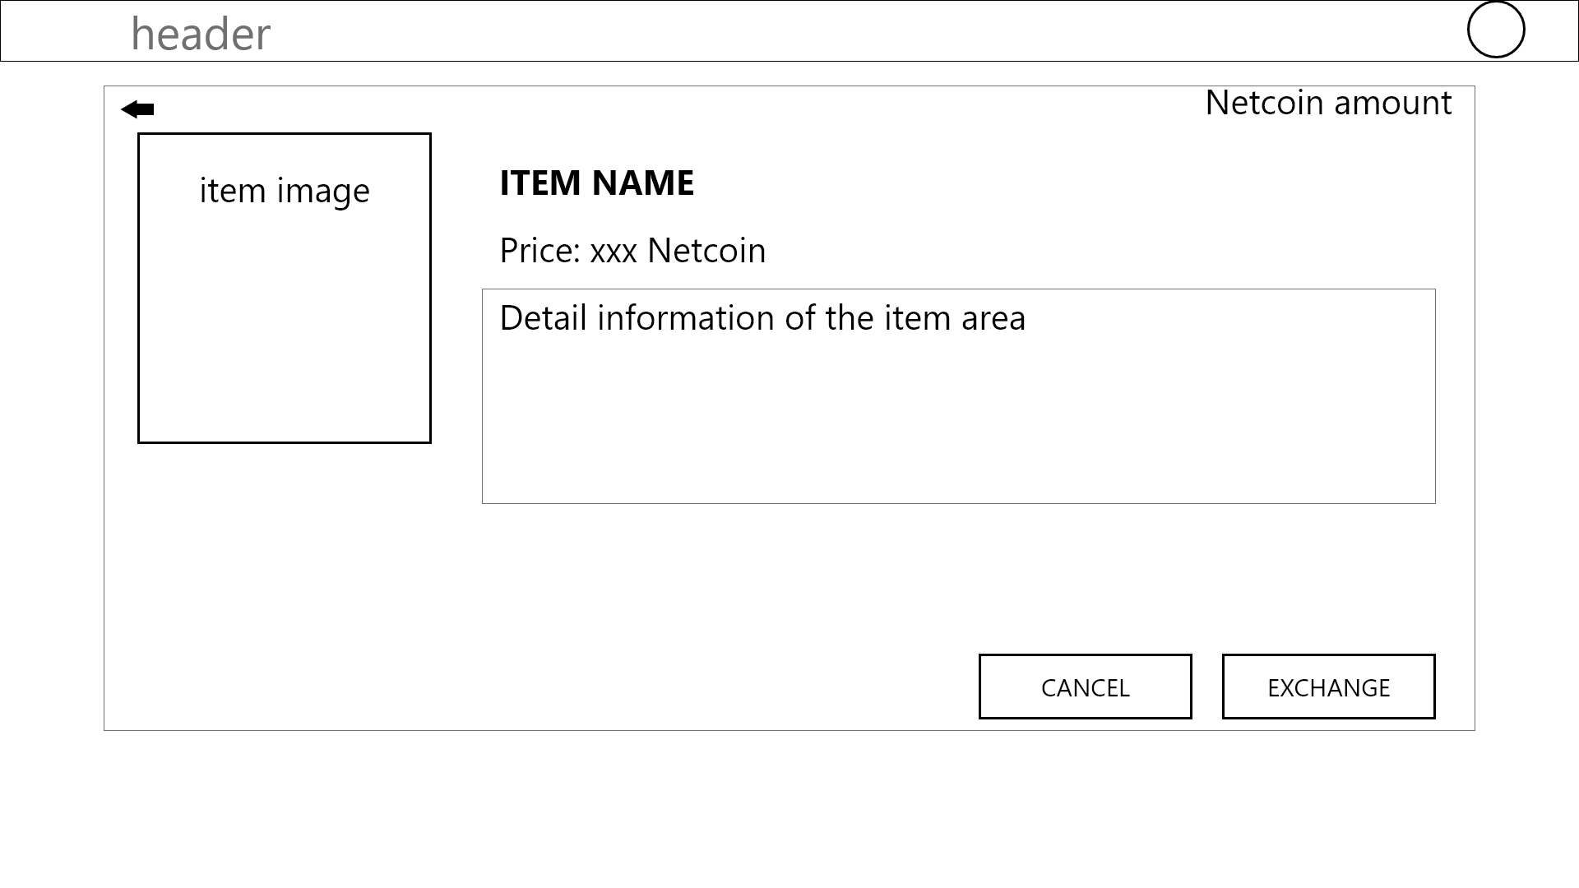

Figure 33 - Exchanging system - Item information

On the top right corner of this figure is the amount of Netcoin the user is having . Next is the image of the current item the user is selecting. Next is the Item name, price and the detail information of that item

Down below are the 2 buttons, on the left side is the cancel button, when clicked it will return the user to the previous page, on the right the right side is the exchange button when clicked it redirects to figure 34.

#### Item Exchanging

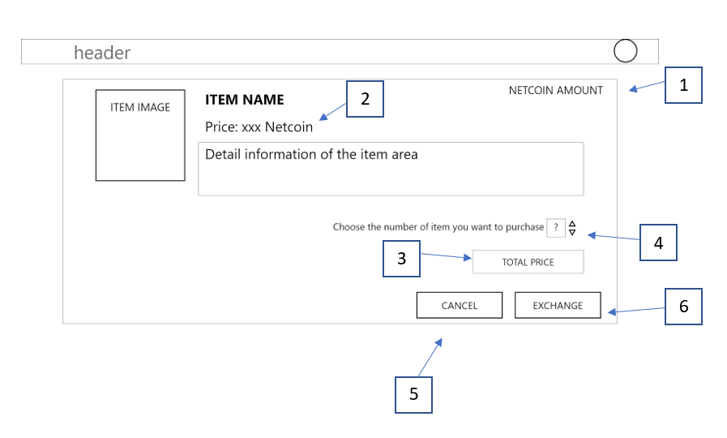Figure 34 - Exchanging system - Item exchanging

In this figure main container, the item image and item information is the same as figure 33. Below is the item quantity the user wants to purchase.Down below is the 2 button, on the left side is the cancel button, when clicked it will return the user to the previous page, on the right the right side is the exchange button when clicked it will purchase the item if the user have enough netcoin and show error if not.

|  |  |  |
| --- | --- | --- |
| Footnote | Component Name | Note |
| 1 | Netcoin amount | Netcoin that the users have. |
| 2 | Item information | Item image, name, price and detail. |
| 3 | Total price | See the price users have to pay for items. |
| 4 | Quantity of item | choose the quantity that user want to purchase |
| 5 | Cancel button | Click to cancel the purchase. |
| 6 | Exchange button | Click to exchange the item. |

#### Netcoin Not Enough

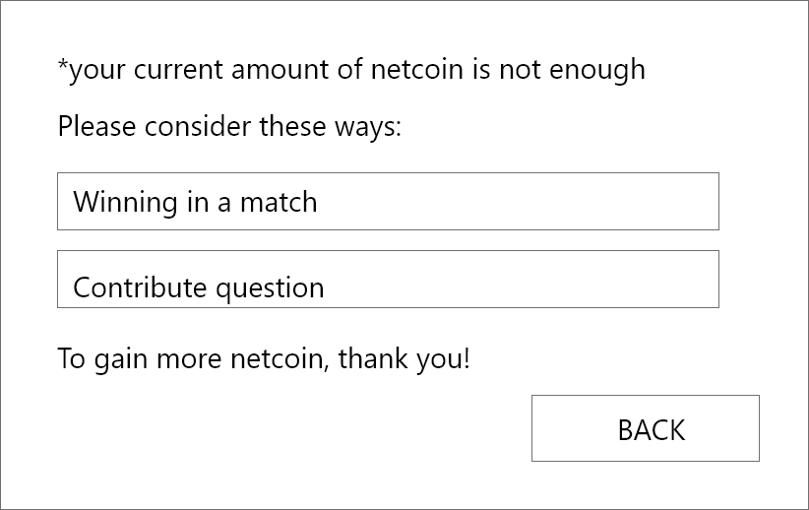

Figure 35 - Exchanging system - Netcoin is not enough

This figure appears when the user purchases an item but the netcoin is not enough, it shows the warning about netcoin is not enough and suggests ways the user can earn more netcoin. There is a back button, when clicked it will return the user to the previous page.

#### Netcoin Enough

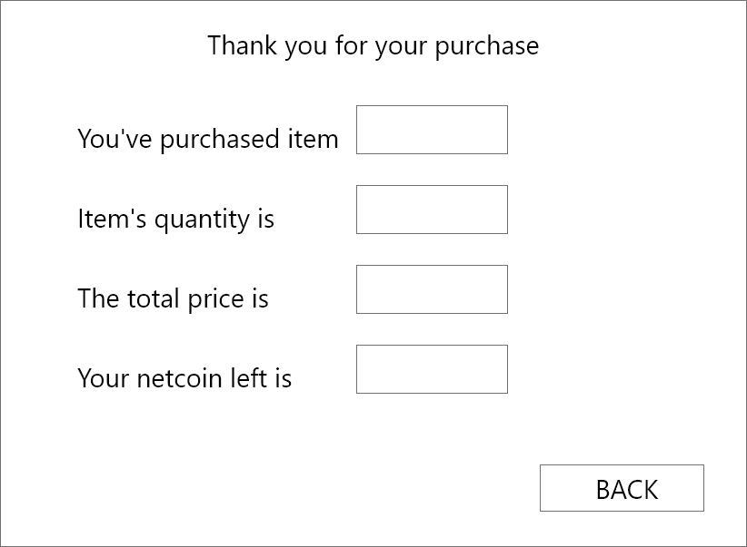

Figure 36 - Exchanging system - Netcoin is enough

This figure appears when the user purchases an item and the netcoin enough, it shows the information of the exchange. There is a back button, when clicked it will return the user to the previous page.

#### Purchase History

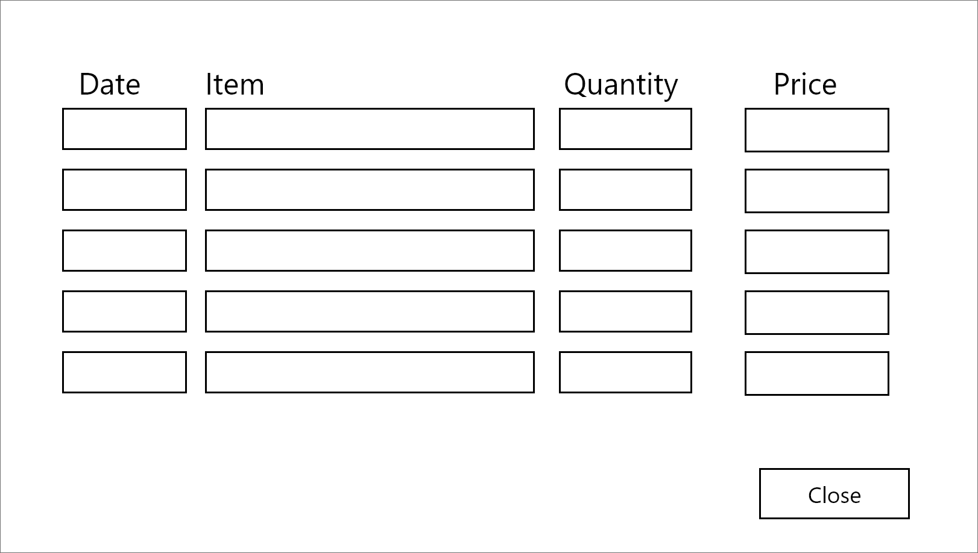

Figure 37 - Exchanging system - Purchase History

This figure appears when the user clicks on the purchase history button, the main containers of this figure consists of the information of the user’s purchase history, including the item name, the date it was purchased, the quantity of that item the user purchased and the total price. There is a close button, when clicked it closes this pop-up and returns to the previous page.

## 

## Profile management

In the figure 23, when click on the information change button, it will redirect to this information layout figure

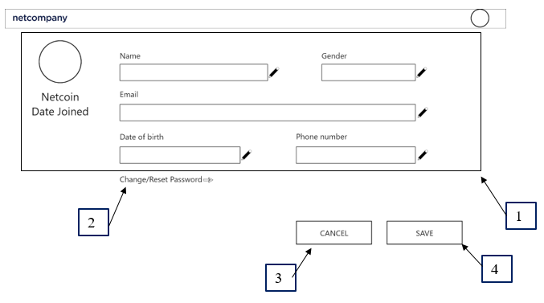

FIgure 38 - Profile management - Profile editing

The layout contains the user information.

|  |  |  |
| --- | --- | --- |
| Footnote | Component Name | Note |
| 1 | User information | The component contains user’s information (Name, gender, dob, email, phone number )which are editable. |
| 2 | Change/Reset password | Let the user change the password |
| 3 | Cancel button | Clicking on he component cancel the changed fields |
| 4 | Save Button | Clicking on the component save the changed fields |

## Gameplay

### Event waiting room

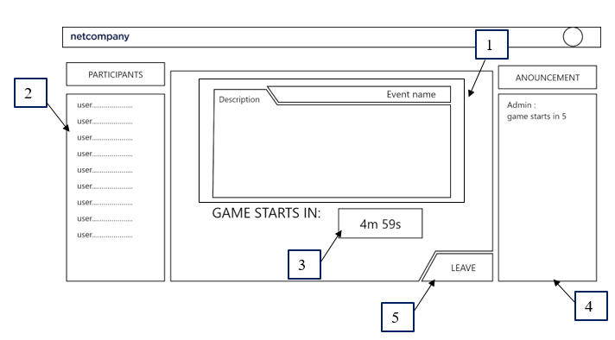

Figure 39 - Gameplay - Event waiting room

In the main container of this figure, on the left side is the participants list, it shows the name of users who already join the waiting room. On the right side is the announcement box,it shows the announcement from the host.

In the middle is the information of the event, including the name of that event, short description and a countdown timer until the game starts. When the timer hits 0, it will change to a join button. When clicked, the join button will join the user to their playing screen (see figure 40).

Last is the leave button, when clicked it will return the user to the previous page.

|  |  |  |
| --- | --- | --- |
| Footnote | Component Name | Note |
| 1 | Event information | Contains event name, description. |
| 2 | Participant list | The component shows all of the user name that joined the event |
| 3 | Timer | Show when the game will start, and after the time is up, the timer will become a join button |
| 4 | Staff announcement | The staff announcement will appear here |
| 5 | Leave Button | Clicking on the button will let the user leave the event |

### Playing room

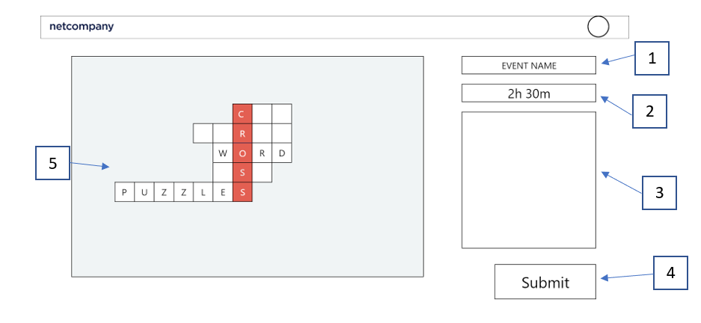

Figure 40 - Gameplay - Playing room

|  |  |  |
| --- | --- | --- |
| Footnote | Component Name | Note |
| 1 | Event information | Event name. |
| 2 | Countdown time | Counting time to end of the event |
| 3 | Question information | Question text-box |
| 4 | Submit button | Clicking on the button will let the user submit the game answer. |
| 5 | Playing room main | The puzzle that users playing |

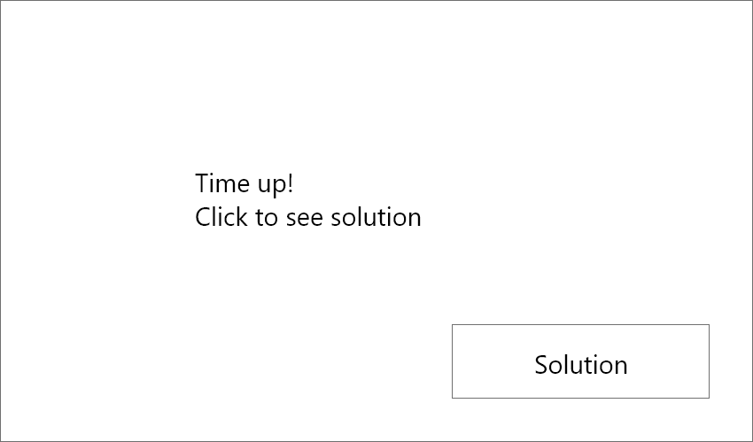

Figure 41 - Gameplay - Time up pop-up

When the countdown timer in the game room (Figure 40) hits 0, the screen is clocked, the answer will be submitted automatically and this figure will show up to announce. There is a solution button, when clicked, it redirects to the solution figure (see figure 42).

### Solution

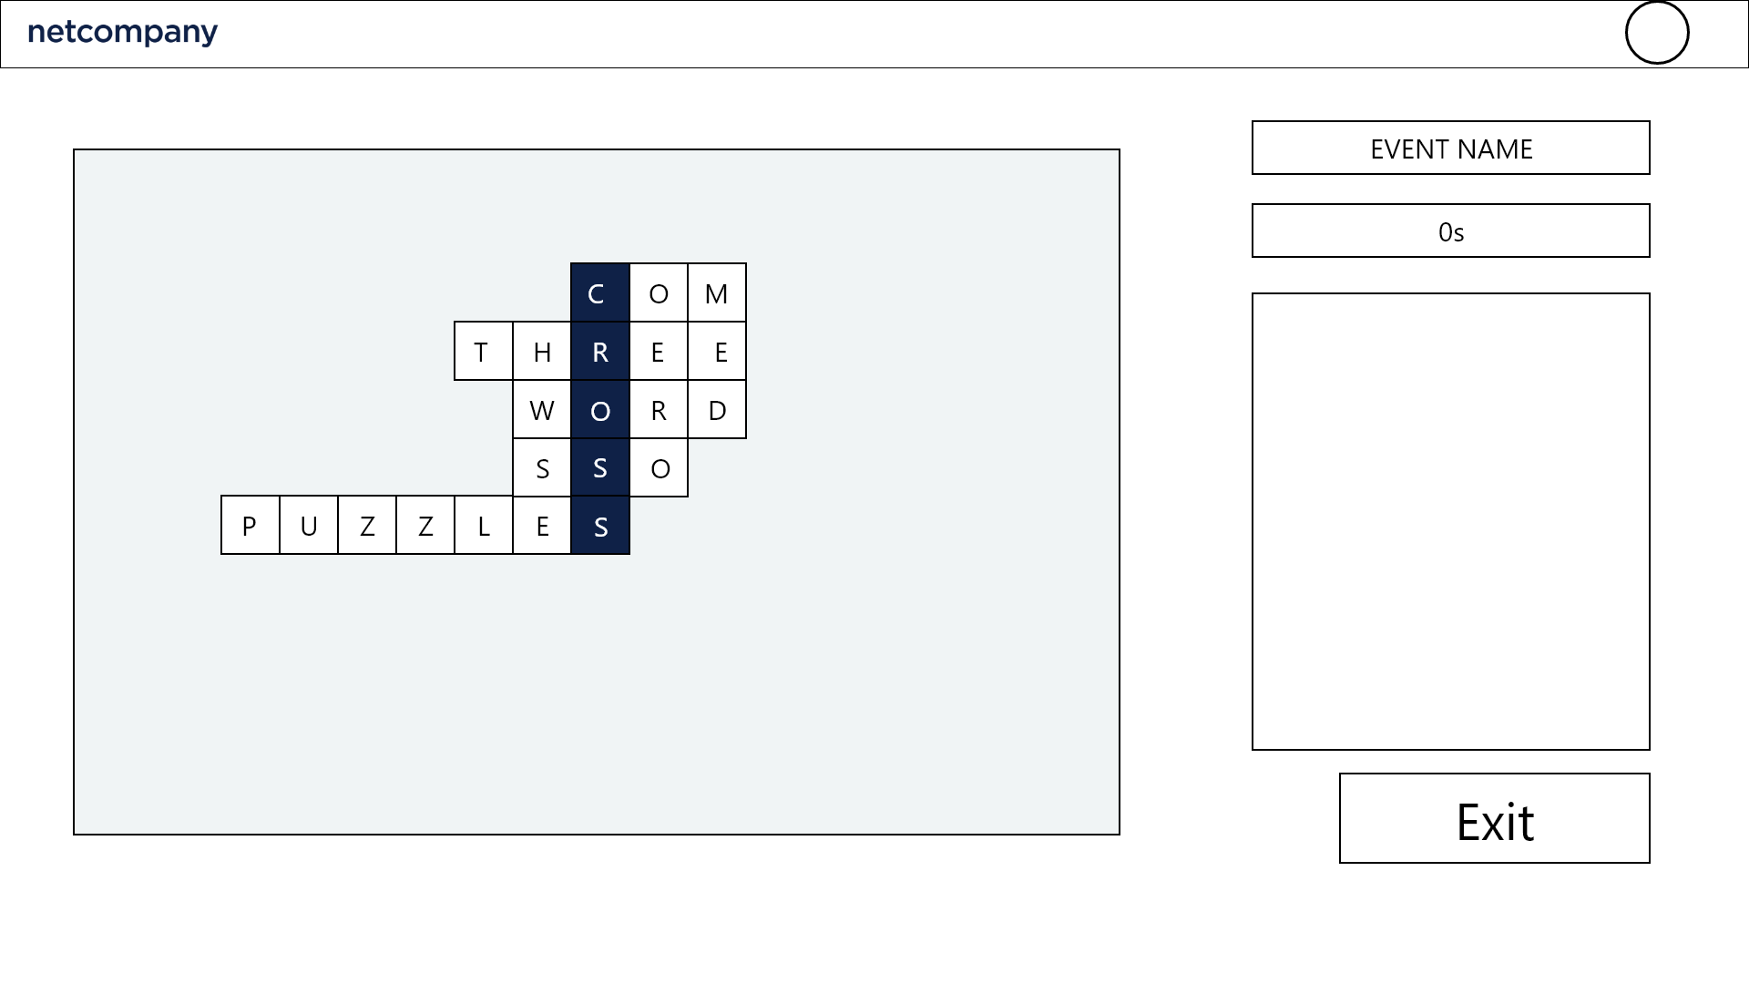

Figure 42 - Gameplay - Solution

The main container in this figure is the same as figure 40, but the puzzle now will also show the solution with it. There is an exit button, when clicked it will redirect to the match result figure (see figure 43).

### Solution

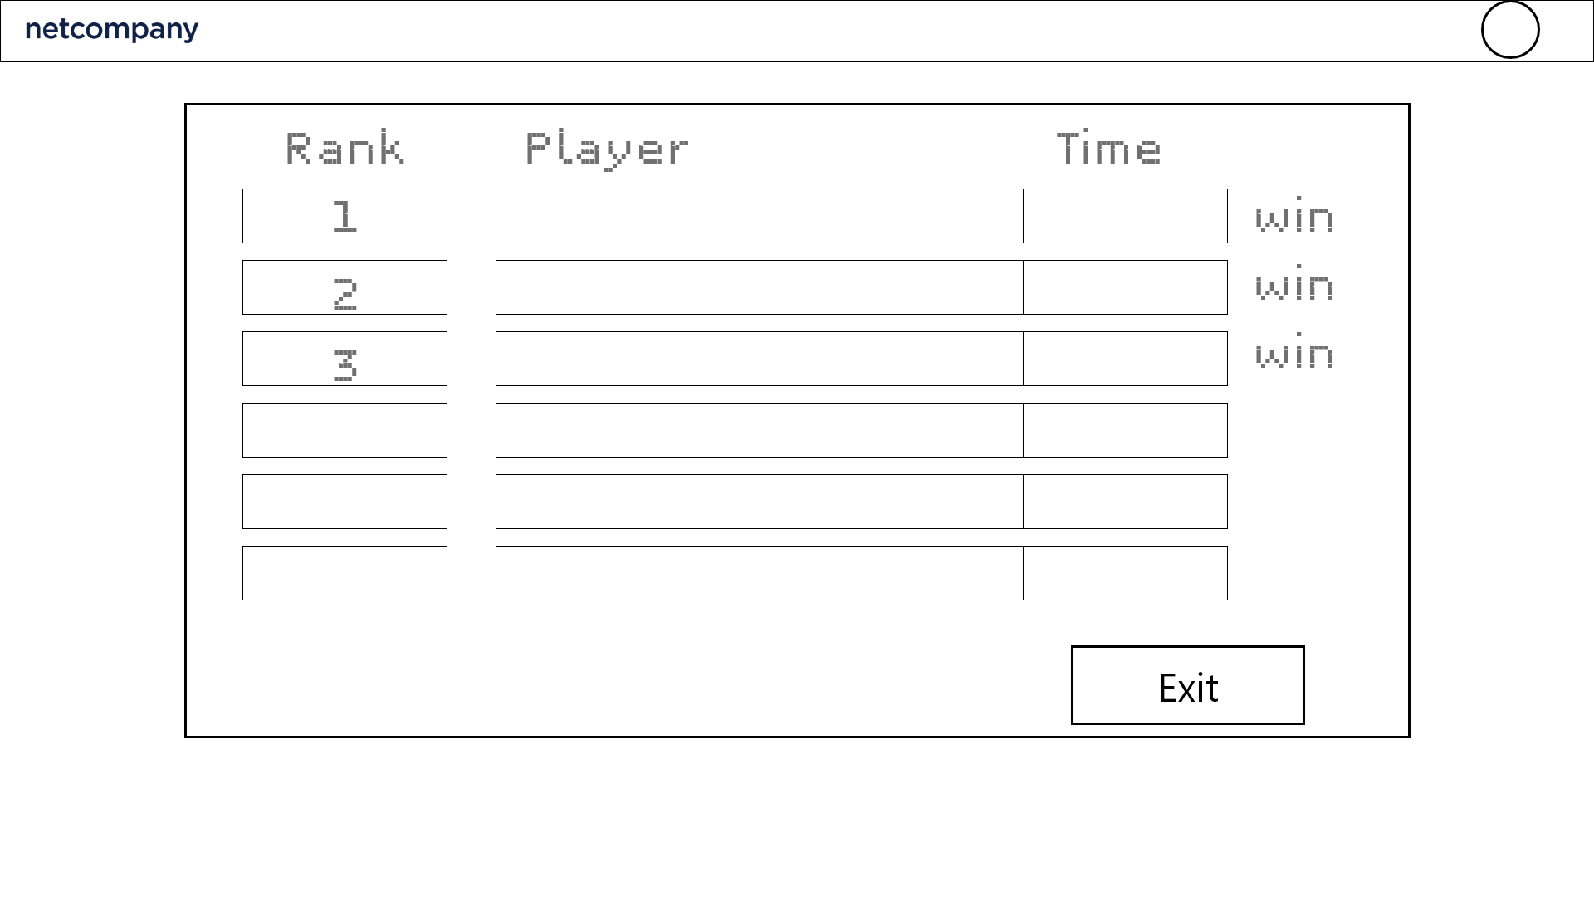

FIgure 43 - Gameplay - Match result

When the game ends, the ranking list of the participants in that game is shown in the form of a list view. The rank of a user is calculated based on the number of questions, the time spent and the difficulty of those questions that the user answered.

There is an Exit button, when clicked it returns the user to the dashboard (see figure 25).